**Sustainable Development Goal14**

**Name : Indumathi S**

**Introduction**

The Sustainable Development Goals (SDGs), also known as the Global Goals, were adopted by all United Nations Member States in 2015 as a universal call to action to end poverty, protect the planet and ensure that all people enjoy peace and prosperity by 2030.

**Goal 14: LIFE BELOW WATER**

Sustainable Development Goal 14 is about "Life below water" and is one of the 17 Sustainable Development Goals established by the United Nations in 2015. The official wording is to "Conserve and sustainably use the oceans, seas and marine resources for sustainable development".

Goal 14 aims to tackle the oceans, calling on the international community to end overfishing and restore fish stocks, protect ecosystems, and eliminate illegal, unreported and unregulated (IUU) fishing.

They are the most diverse and important ecosystem, contributing to global and regional elemental cycling, and regulating the climate. The ocean provides natural resources including food, materials, substances, and energy. Also, Oceans and fisheries support the global population’s economic, social and environmental needs. Oceans are the source of life of the planet and the global climate system regulator.

The Goal 14 has ten targets to be achieved by 2030. Progress towards each target is being measured with one indicator each.

**Target 14.1: Reduce marine pollution**

By 2025, prevent and significantly reduce marine pollution of all kinds, in particular from land-based activities, including marine debris and nutrient pollution

This target has two indicators they are

#### **Indictors14.1.1:**

(a) Index of coastal eutrophication

1.1.1. Chlorophyll-a deviations (remote sensing)

1.1.2. Chlorophyll-a anomaly, remote sensing (%)

(b) plastic debris density

1.1.1.Beach litter originating from national land-based sources

**Target 14.2: Protect and restore ecosystems**

"By 2020, sustainably manage and protect marine and [coastal ecosystems](https://en.wikipedia.org/wiki/Coast) to avoid significant adverse impacts, including by strengthening their resilience, and take action for their restoration in order to achieve healthy and productive oceans"

#### **Indicator 14.2.1:**

"The proportion of national [exclusive economic zones](https://en.wikipedia.org/wiki/Exclusive_economic_zone) managed using ecosystem-based approaches".

### **Target 14.3: Reduce ocean acidification**

Minimize and address the impacts of ocean acidification, including through enhanced scientific cooperation at all levels

**Indicator 14.3.1:**

(a). Average marine acidity (pH) measured at agreed suite of representative sampling stations

3.1.1.Average marine acidity (pH) measured at agreed suite of representative sampling stations

### 

### **Target 14.4: Sustainable fishing**

By 2020, effectively regulate harvesting and end overfishing, illegal, unreported and unregulated fishing and destructive fishing practices and implement science-based management plans, in order to restore fish stocks in the shortest time feasible, at least to levels that can produce maximum sustainable yield as determined by their biological characteristics

**Indicator 14.4.1:**

a. Proportion of fish stocks within biologically sustainable levels

4.1.1 Proportion of fish stocks within biologically sustainable levels (not overexploited) (%)

**Target14.5 Conserve coastal and marine areas**

By 2020, conserve at least 10 per cent of coastal and marine areas, consistent with national and international law and based on the best available scientific information

**Indicator 14.5.1:**

a. Coverage of protected areas in relation to marine areas

5.1.1 . Protected marine area (Exclusive Economic Zones) (square kilometres)

5.1.2 Average proportion of Marine Key Biodiversity Areas (KBAs) covered by protected areas (%)

### **Target 14.6: End subsidies contributing to overfishing**

By 2020, prohibit certain forms of fisheries subsidies which contribute to overcapacity and overfishing, eliminate subsidies that contribute to illegal, unreported and unregulated fishing and refrain from introducing new such subsidies, recognizing that appropriate and effective special and differential treatment for developing and least developed countries should be an integral part of the World Trade Organization fisheries subsidies negotiation

**Indicator 14.6.1:**

a.) Progress by countries in the degree of implementation of international instruments aiming to combat illegal, unreported and unregulated fishing

6.1.1 Progress by countries in the degree of implementation of international instruments aiming to combat illegal, unreported and unregulated fishing (level of implementation: 1 lowest to 5 highest)

### **Target 14.7: Increase the economic benefits from sustainable use of marine resources**

By 2030, increase the economic benefits to Small Island Developing States and least developed countries from the sustainable use of marine resources, including through sustainable management of fisheries, aquaculture and tourism

**Indicator 14.7.1:**

A sustainable fishery as a percentage of GDP in small island developing States, least developed countries and all countries

7.1.1 Sustainable fisheries as a proportion of GDP

### **Target 14.a: Increase scientific knowledge, research and technology for ocean health**

Increase scientific knowledge, develop research capacity and transfer marine technology, taking into account the Intergovernmental Oceanographic Commission Criteria and Guidelines on the Transfer of Marine Technology, in order to improve ocean health and to enhance the contribution of marine biodiversity to the development of developing countries, in particular small island developing States and least developed countries

**Indicator 14.a.1:**

a. Proportion of total research budget allocated to research in the field of marine technology

a.1.1 National ocean science expenditure as a share of total research and development funding (%)

### **Target 14.b: Support small scale fishers**

Provide access for small-scale artisanal fishers to marine resources and markets

**Indicator 14.b.1**

a. Progress by countries in the degree of application of a legal/regulatory/policy/institutional framework which recognizes and protects access rights for small-scale fisheries

b.1.1. Degree of application of a legal/regulatory/policy/institutional framework which recognizes and protects access rights for small-scale fisheries (level of implementation: 1 lowest to 5 highest)

### **Target 14.c: Implement and enforce international sea law**

Enhance the conservation and sustainable use of oceans and their resources by implementing international law as reflected in the United Nations Convention on the Law of the Sea, which provides the legal framework for the conservation and sustainable use of oceans and their resources, as recalled in paragraph 158 of “The future we want”

**Indicator 14.c.1:**

a. Number of countries making progress in ratifying, accepting and implementing through legal, policy and institutional frameworks, ocean-related instruments that implement international law, as reflected in the United Nations Convention on the Law of the Sea, for the conservation and sustainable use of the oceans and their resources

c.1.1 Score for the implementation of UNCLOS and its two implementing agreements (%)

**Problem Statement and Objectives:**

1. To analyse the level of each country to achieve the target14.
2. To analyse the top 5 countries and worst 5 countries for each indicator.
3. To analyse the indicators by continent wise measure.
4. To observe the trends, patterns and variation of each continent by indicators value.

### **Analysis:**

**Exploratory analysis:**

By the observations, the data set has many empty columns and some of the indicators have more NaN which are Indicator 14.4.1, 14.6.1, 14.7.1, 14.b.1. So, the unnecessary columns and indicators have been dropped. Then by info, the datatype of variables has been found. From this, we found that the datatype for value is object and time period is integer. So the datatype for value has been changed as float and datatype for time period is changed as object. After that, we have filled the zero for NaN values. The cleaned data is given below

**Cleaned Data**

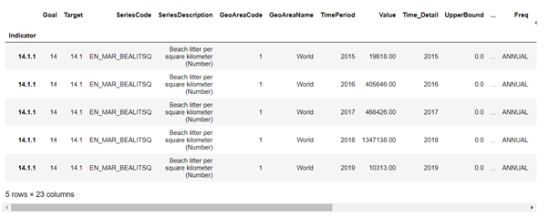

**Analysis for Indicator 14.1.1 - beach litter per square kilometre**

**Data frame for beach litter per square kilometre indicator:**

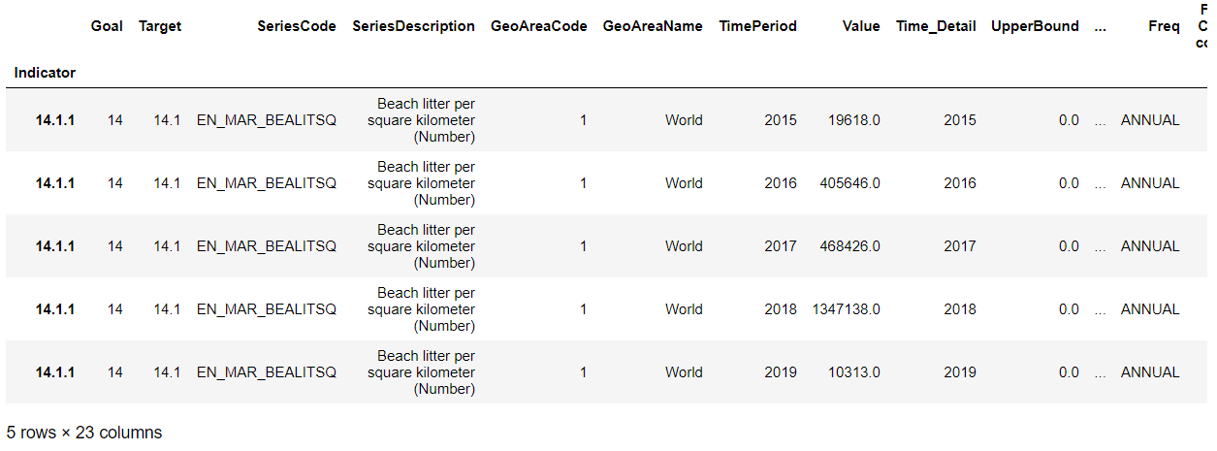

**Choosing five top and worst countries for polluting the ocean:**

**Mean of the beach litter quantity per square kilometre for each country**

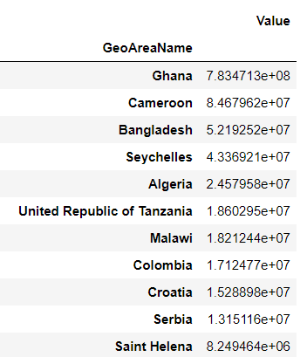

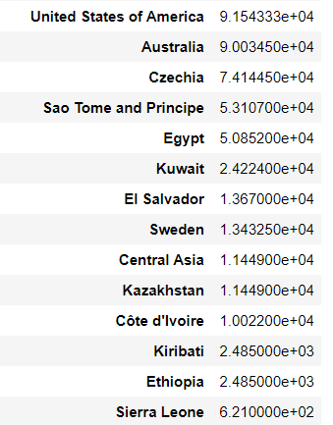

From the table, the best and worst countries of polluting oceans have been found. **The top five countries polluting the ocean more are Ghana, Cameroon, Bangladesh, Seychelles, Algeria. The bottom five countries polluting the ocean less are Sierra Leone, Ethiopia', 'Kiribati, Côte d'Ivoire, Central Asia**

**Pivot table for average beach litter value of country for each year**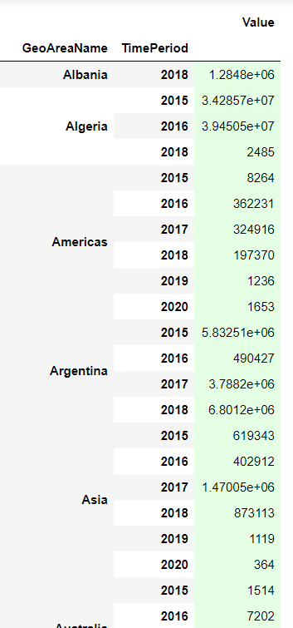

The above five countries are having the ‘Beach litter’ value higher than the other countries which implies these countries are affected most by the pollutants in Oceans.

**Spatio Temporal Analysis for best and worst countries of polluting ocean:**

1. **Space fixed time varying**

* **Line plot for country Ghana polluting the ocean over the years**

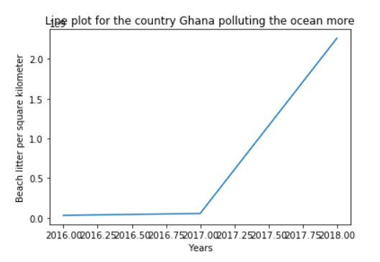

|  |
| --- |
| The beach litter in 2016 and 2017 were nearly the same. After 2017, the value of beach litter increased. Beach litter per square kilometre (Number) value is increasing, as the year increases for the country Ghana. That is the garbage in the Oceans is increasing day by day in country Ghana. |

* **Line plot for the country polluting the ocean less**

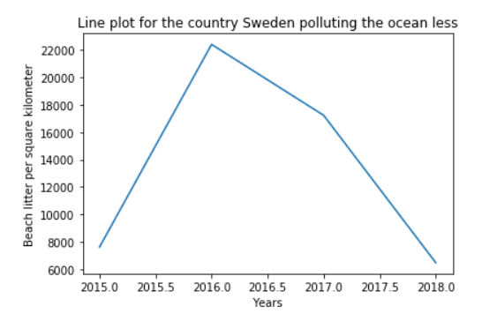

From the plot it is clear that Country Sweden Beach litter is maximum in the year of 2016. There is a constant increase in Beach litter per kilometer of country Sweden from 2015 to 2016 then started a decline in the Sweden in Beach litter from 2016 to 2018.

**b) Both time and space varying**

* **Line plot for the five countries polluting the ocean more**

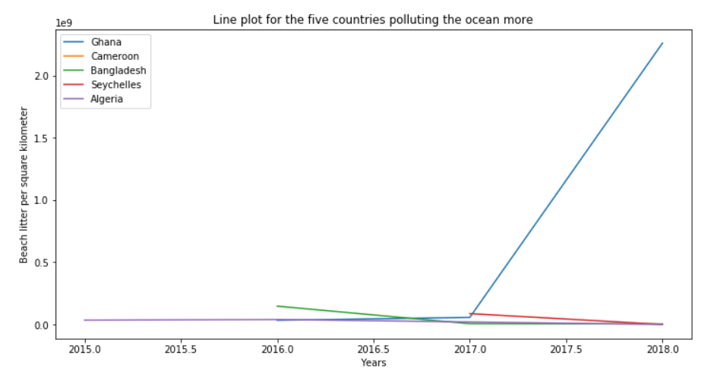

The above five countries polluted the ocean more, particularly Ghana marine debris is maximum than other countries. Therefore, we can tell that the above five continents are the major contributors to their respective continent.

* **The plot for the five countries polluting the ocean less**

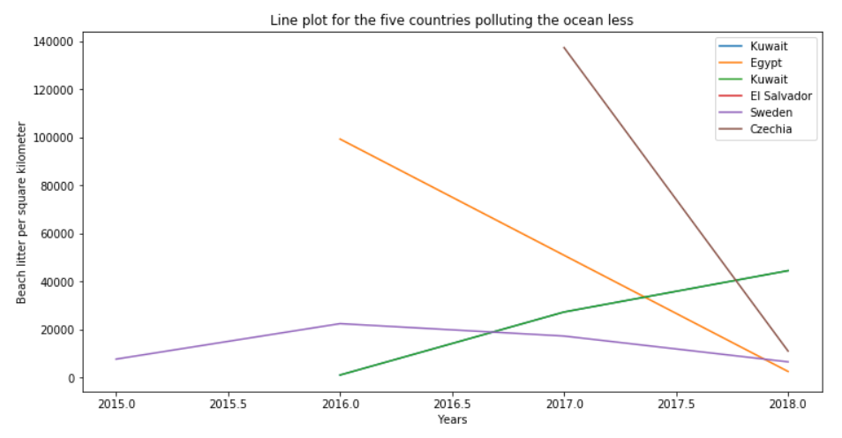

The above five countries pollute the ocean less, in 2018 marine debris minimum. Therefore we can tell that the above five continents are the major supporters to preserve the Oceans to their respective continent.

**c) Time fixed(2018) and space varying**

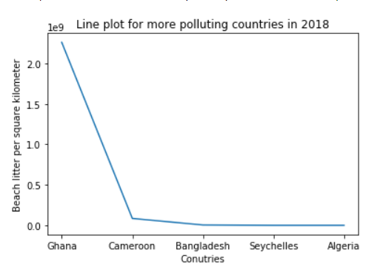

In 2018 Country Ghana Beach litter per square kilometre is higher than other countries.

## 

Country Beach litter per kilometre is the highest for Kuwait when compared to other worst countries in 2018.

## **Continent analysis:**

Here we analysed the polluted oceans in continent wise by which continent polluted the ocean maximum.

**Dataframe for beach litter of continents:**

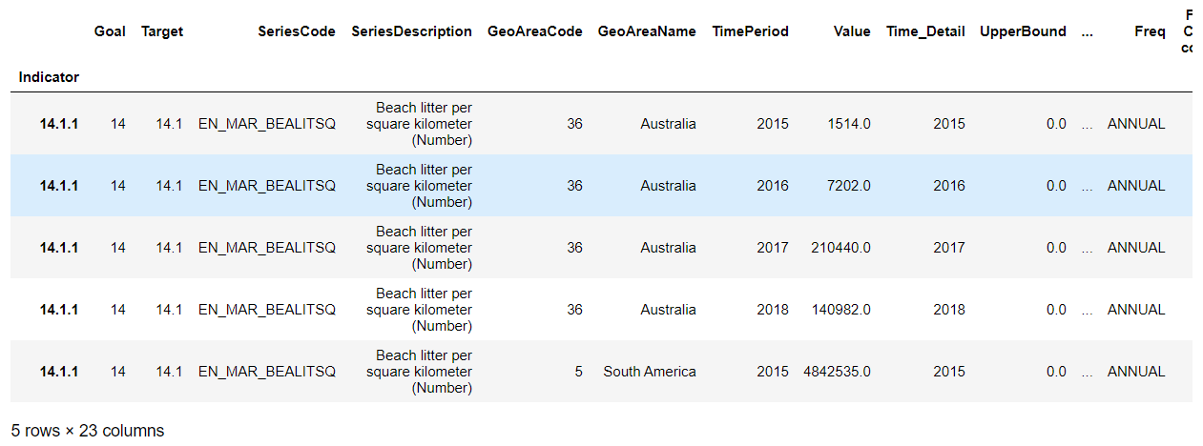

**Pivot Table for average beach litter per square kilometre with respect to continent and year**

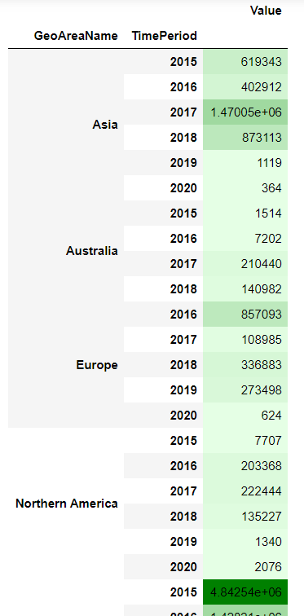

**Bar plot for the Values of the continents of Beach Litter Indicator**

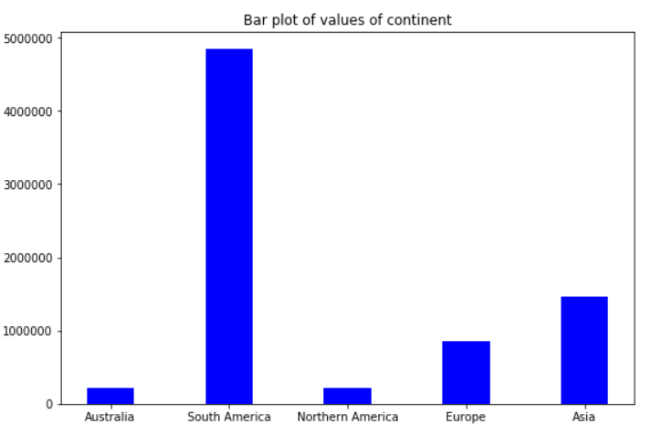

Continent South America polluted the ocean higher than other continents. Asia is the second highest. North America is polluting less than other continents. North America and South America Beach litter per Kilometer are not even comparable.

## **Time Series Analysis for continents**

* **Lag Plot of continents for indicator beach litter**

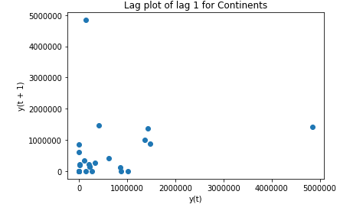

The above graph is a lag plot for lag1 for continents. Lag 1 for continents is uncorrelated i.e) the beach litter of continents are correlated itself with lag 1.

* **Autocorrelation Plot of continents for indicator beach litter**

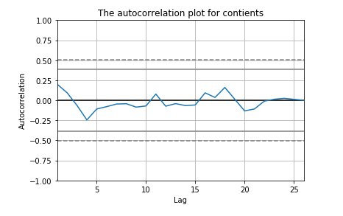

The correlation for all lags lie between the threshold line which indicates the no autocorrelation for continents.

**Trend & seasonal plot**

#### **Trend:**

The trend shows a general direction of the time series data over a long period of time. A trend can be increasing(upward), decreasing(downward), or horizontal(stationary).

#### **Seasonality:**

A repeating pattern within some period over time is known as seasonality.

* **Seasonal plot for Asia**

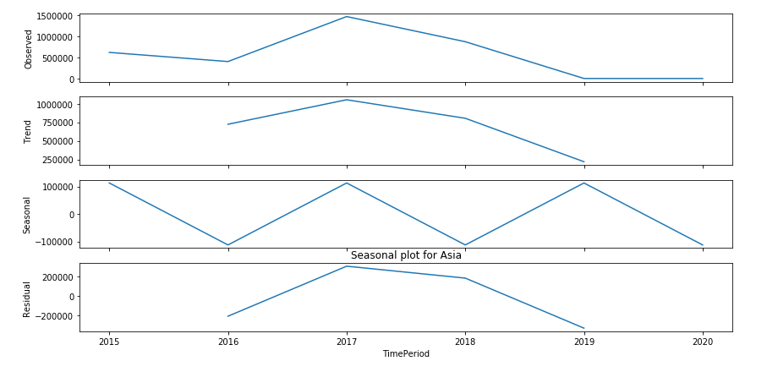

From the trend plot, we can infer that the trend of the beach litter of asia is decreasing over the years. From the seasonal plot, we can see that there is a pattern every two years. That is, in 2015, the beach litter of asia is decreasing and again increasing in next year likewise the seasonality goes on.

* **Seasonal plot for Australia**

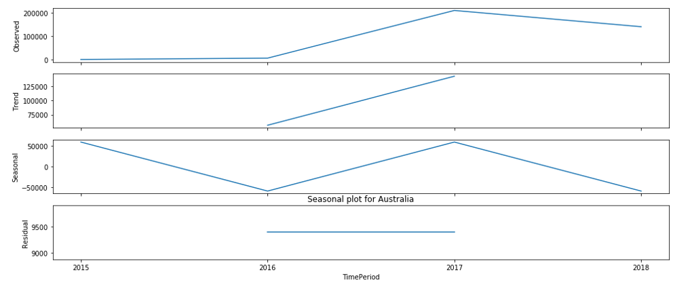

From the trend plot, we can infer that the trend of the beach litter of Australia is increasing over the years. From the seasonal plot, we can see that there is a pattern every two years. i.e) In 2016, the beach litter of Australia is decreasing and again increasing in next year likewise the seasonality goes on. That is 2019 beach litter will increase.

* **Seasonal plot for Europe**

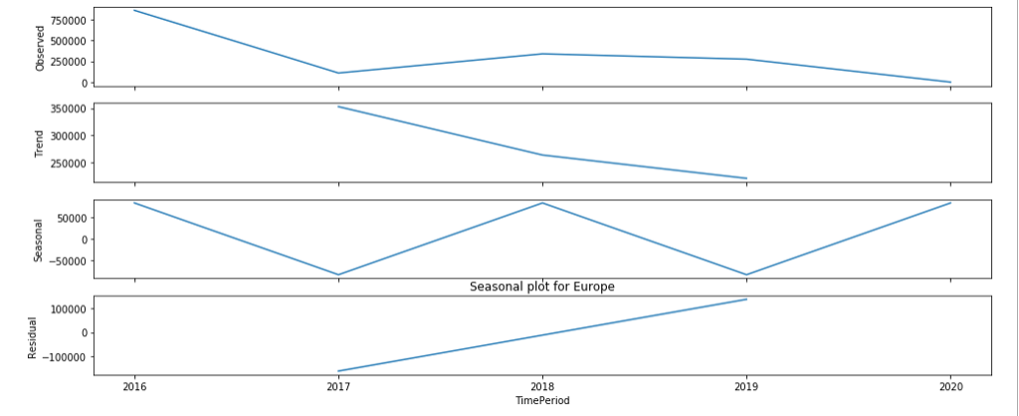

From the trend plot, we can infer that the trend of the beach litter of Europe is decreasing over the years. From the seasonal plot, we can see that there is a pattern every two years. i.e) In 2017, the beach litter of Europe is decreasing and again increasing in next year likewise the seasonality goes on. That is 2021 beach litter will decrease for Europe.

* **Seasonal plot for North America**

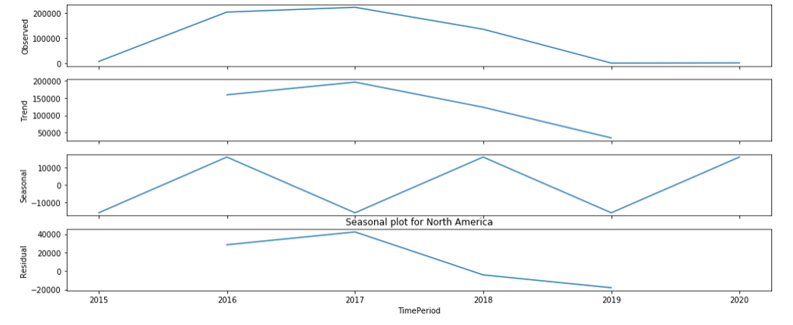

From the trend plot, we can infer that the trend of the beach litter of North America is decreasing over the years. From the seasonal plot, we can see that there is a pattern every two years. That is in 2015, the beach litter of North America was decreasing and again it was increasing in next year likewise the seasonality goes on. That is 2021 beach litter will decrease.

* **Seasonal plot for South America**

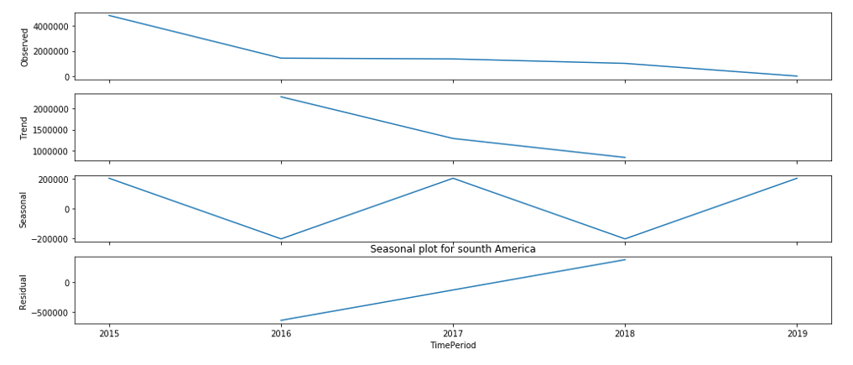

From the trend plot, we can infer that the trend of the beach litter of South America is decreasing over the years. From the seasonal plot, we can see that there is a pattern every two years. That is in 2016, the beach litter of South America was decreasing and again it was increasing in next year likewise the seasonality goes on

## **Spatio Temporal Analysis for continents:**

1. **Space fixed and time varying**

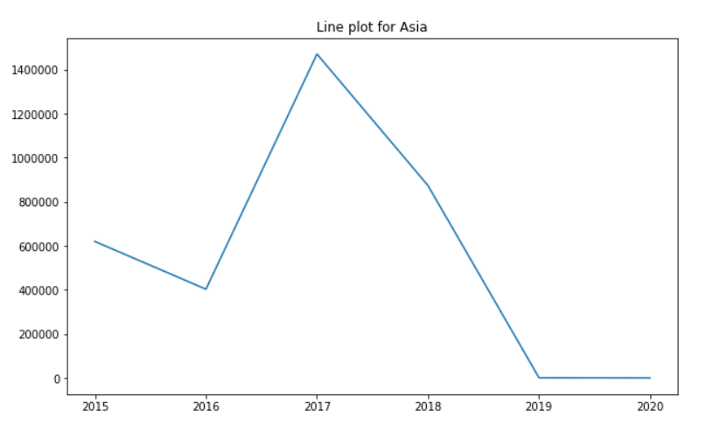

Beach litter per kilometer is maximum in the year 2017 and then started to decline from the year 2017 to 2019 and then the main constant which shows the positive indication that continent Asia is taking remedial measures to reduce the Beach litter per kilometer.

**b) Both time and space varying**

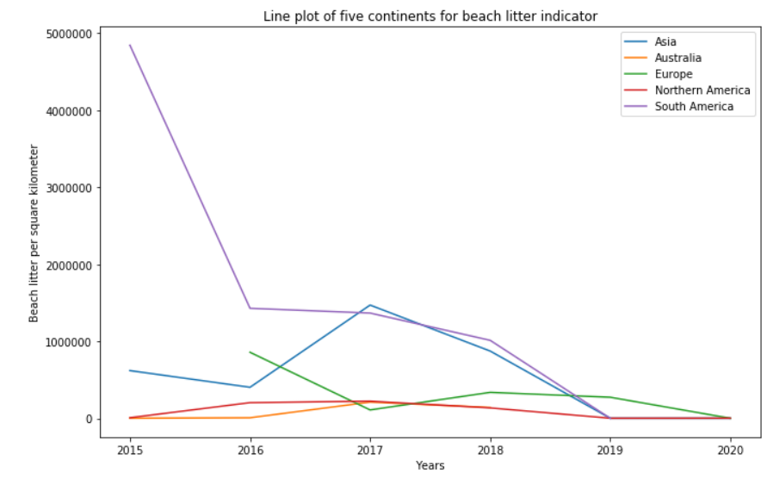

Here we can observe the Beach litter per kilometer for each year and each continent. In the year 2015 South America polluted the Ocean the most, after 2015 there is a decline in the Beach litter per kilometer which is the positive indication that South America took the remedial measures to decrease the Beach litter per kilometer. Other Continent Polluted the ocean less than South America. Also other continents maintain almost constant the Beach litter per kilometer from 2015 to 2020 except Asia. South America's contribution to the global marine debris in 2015 had been so high such that its contribution to the same in 2016 which was intensely controlled and much reduced, was still higher than the other continents.

**c) Time fixed and space varying**

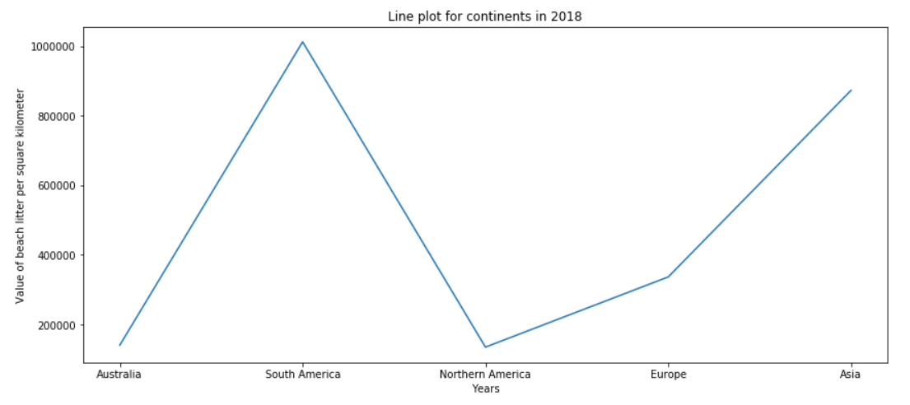

Australia and North America polluted the Ocean less than other continents in the year 2018 because Beach litter per kilometer is less than the other. South America’s value is maximum in 2018, Asia’s value also approximately almost equal to South America. So, from this we can tell that in 2018 the Continent Asia and South America polluted the Ocean most. These two continents are major contributors to the world marine debris.

**Inference for Indicator 14.1.1 (Beach litter)**

From the analysis it is clear that continent South America marine litter is maximum which is the major contributor to the world marine debris. In the year 2015 South America polluted the Ocean the most, after 2015 there is a decline in the Beach litter per kilometer which is the positive indication that South America took the remedial measures to decrease the Beach litter per kilometer. Other Continent Polluted the ocean less than South America. In 2020 Europe and North America marine debris will be almost the same. South America’s marine debris is maximum in 2016 but it reduced marine debris in 2019 where South America and North America marine debris is almost the same.

**Analysis for Indicator 14.3.1- Average marine acidity (pH):**

This indicator is used to measure the ocean acidification. Ocean acidification is the ongoing decrease in the pH of the oceans, caused by carbon dioxide gas in the atmosphere dissolving into the ocean. Using this indicator, we can progress the average marine acidity. Generally, the pH is less than 7 is considered as acid. So the pH tending to 7 is considered as worst and pH tending to 8 is considered as good

**Dataframe for Indicator - Average marine acidity (pH)**

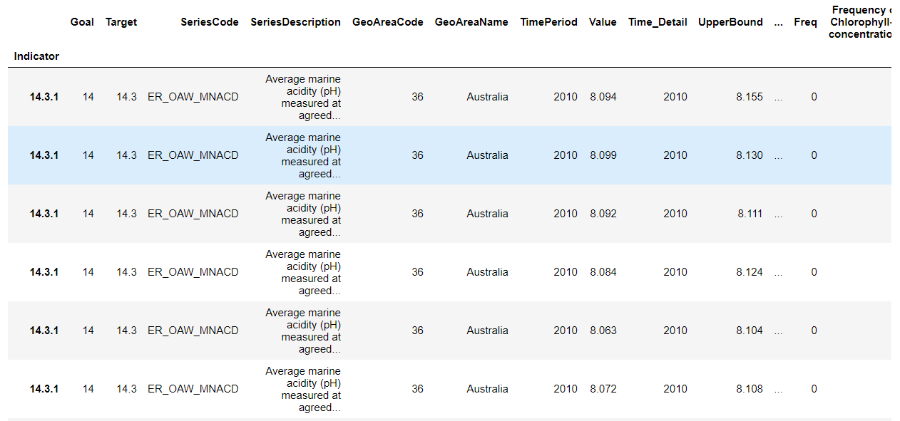

**Average of marine acidity of every year for each country:**

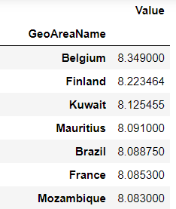

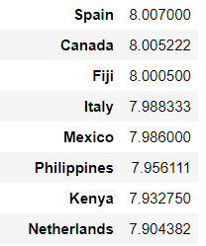

From the table, the best and worst countries for average of marine acidity have been found. **The top five countries which have more marine acidity are 'Belgium', 'Finland', 'Kuwait', 'Mauritius', 'Brazil'. The bottom five countries which have lass marine acidity are 'Netherlands', 'Kenya', 'Philippines', 'Mexico', 'Italy'**

**Spatio Temporal Analysis:**

1. **Space fixed time varying**

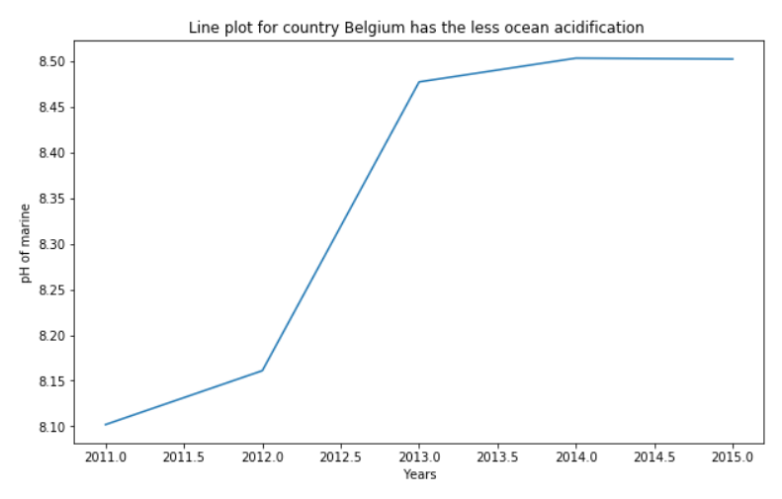

The graph shows that the pH of the ocean in Belgium is increasing which is a positive indication and it tells that the carbon dioxide is less in the atmosphere in Belgium.

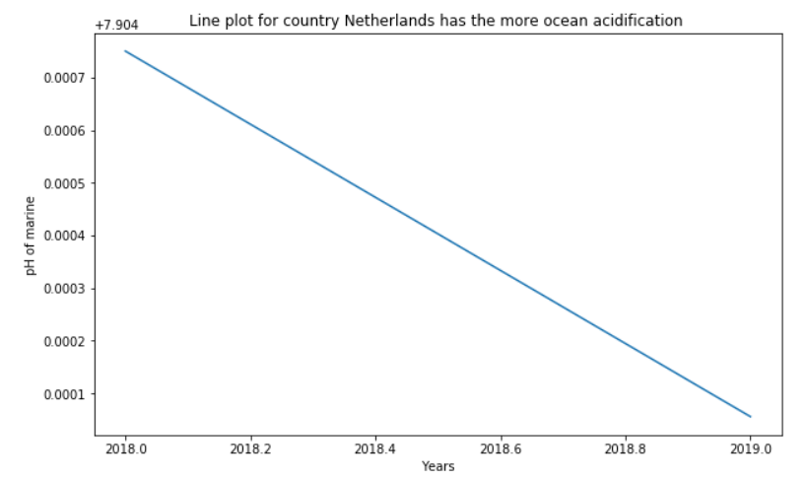

The above graph shows that the pH of the ocean in Netherland is decreasing from 7.9047 to 7.9041 which is a negative indication and also it tells that the carbon dioxide is more in the atmosphere in Netherland which is dissolving in the ocean.

1. **both time and space varying**

* **The countries have less ocean acidification**

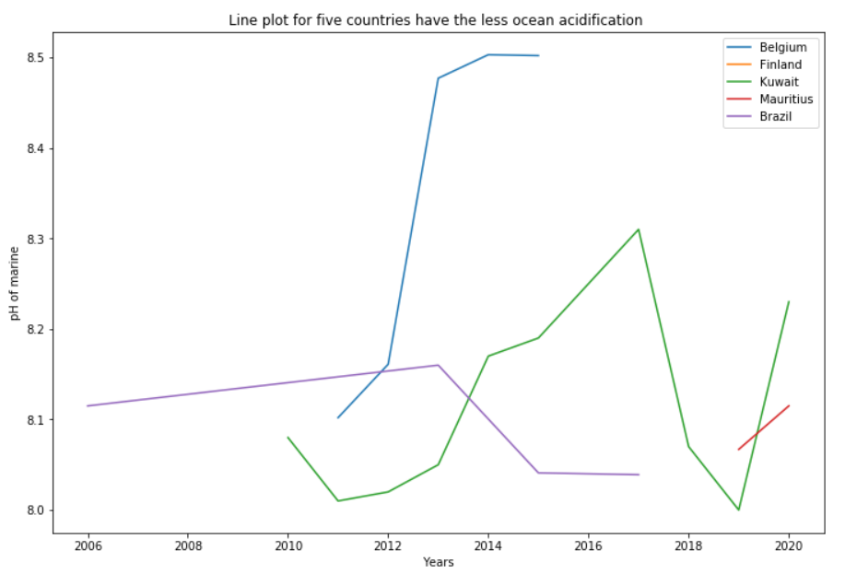

From the comparison graph, we can see that the pH of the ocean in Belgium has drastically increased in 2012-13. The pH of the ocean in Brazil is higher than other countries till 2016. The pH of the ocean in Brazil is high only but it’s decreasing over time which is not a good sign

* **The countries have more ocean acidification**

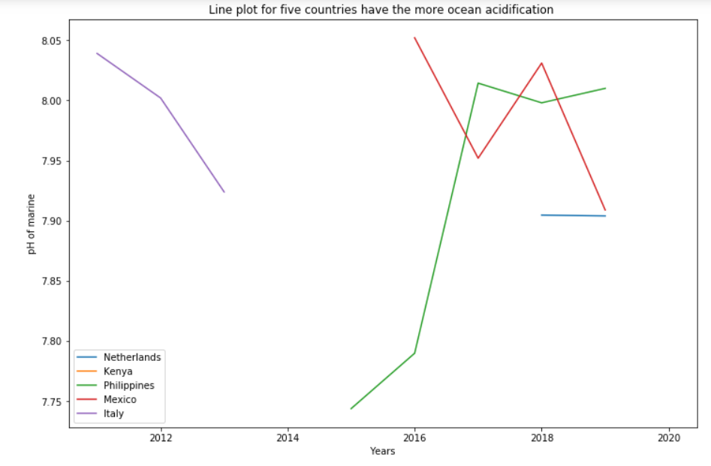

The above graph tells that the pH of the ocean in philippines in 2015 is very low but in 2017 the pH level is increasing more which tells that they took the measures to reduce the carbon dioxide in the atmosphere which is a positive indication. But other countries' pH is decreasing over time.

**c) Time fixed and space varying**

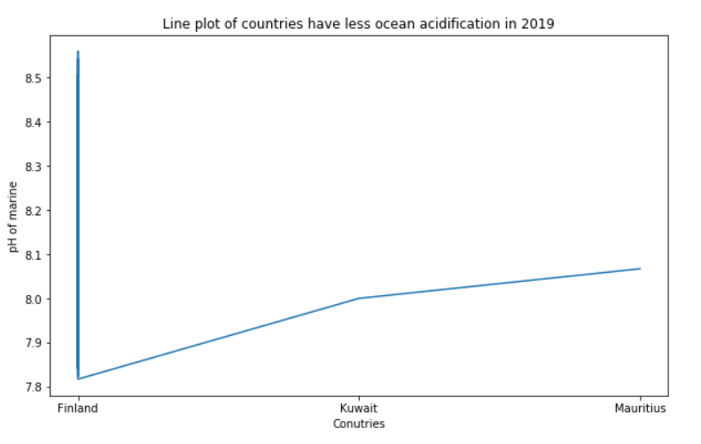

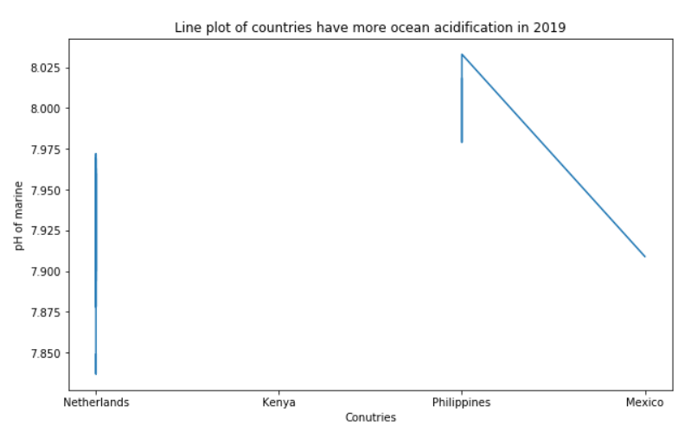

**Continent wise analysis of Marine Acidity**

The data for Marine acidity is only available for Australia.

* **Lag Plot of continents for indicator Marine Acidity**

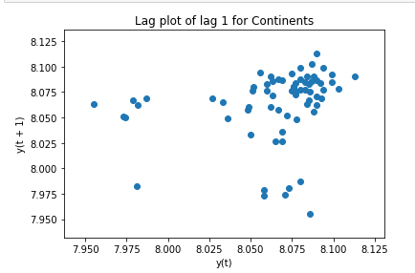

The above graph is a lag plot for lag1 for continents. Lag 1 for continents is uncorrelated that is, the beach litter of continents is correlated itself with lag 1.

* **Autocorrelation Plot of continents for indicator beach litter**

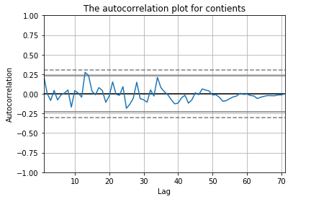

The correlation for all lags lies between the threshold line which indicates the no autocorrelation for continents.

## **Spatio Temporal Analysis for continents:**

* **Space fixed and time varying**

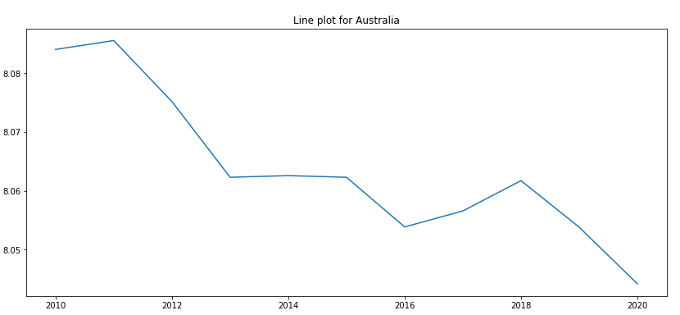

In 2010, the pH of the ocean in Australia was high but it decreased over time which tells that the carbon dioxide was increasing in the atmosphere over time which is not a good indication.

**Analysis for Indicator 14.1.1-Chlorophyll-a deviations, remote sensing (%)'**

Chlorophyll-a deviation is the important factor because plants and animals under water need Chlorophyll. If the chlorophyll deviation value is maximum then Ocean animals and plants may affect due to insufficient Chlorophyll. This may lead to death of animals and plants.

**Dataframe for Indicator 14.1.1-Chlorophyll-a deviations, remote sensing (%)'**

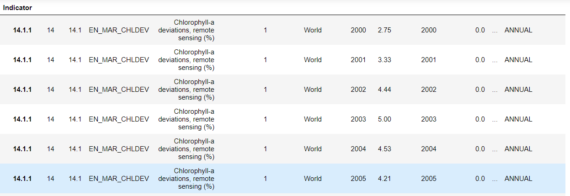

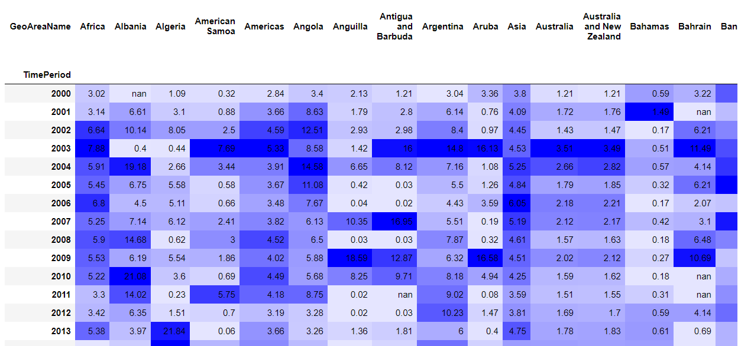

Dark blue cells indicate the maximum deviation of each country and mild color indicates the less deviation of chlorophyll. If there is less deviation then those countries will get sufficient deviation and dark blue cells are in the danger zone those countries should take remedy to overcome this situation.

**Pivot table for value of chlorophyll deviation for each year:**

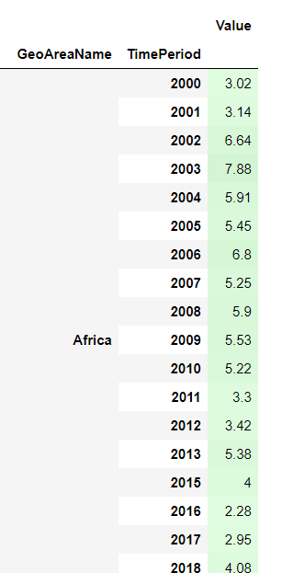

**Average percentage of Chlorophyll-a deviations**

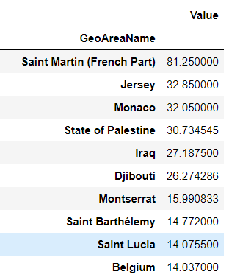

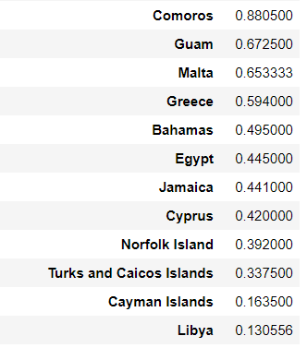

From the table, the best and worst countries for average chlorophyll-a deviation have been found. **The top five countries having high chlorophyll deviation in the ocean are 'Saint Martin (French Part)', 'Jersey','Monaco', 'State of Palestine','Iraq'. The bottom five countries having less chlorophyll deviation are 'Libya','Cayman Islands','Turks and Caicos Islands',”Norfolk Island","Cyprus"**

**Spatio Temporal Analysis for best and worst countries:**

1. **Space fixed and time varying**

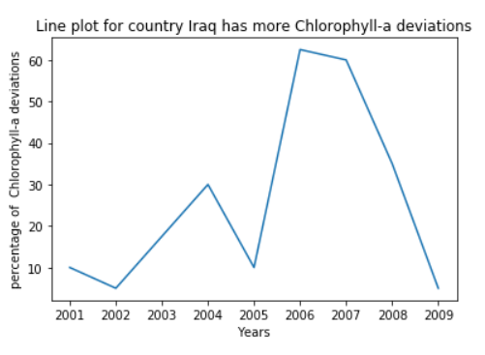

Chlorophyll-a deviation is minimum in 2002 for Iraq and then deviation was increasing and reached its maximum in 2006. Then it started decreasing, in 2009 again it declined. It is not following any trend at random year it reached maximum and minimum.

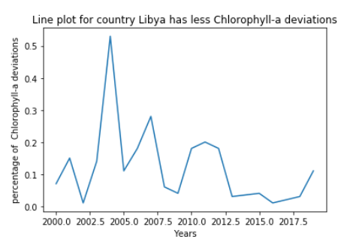

Chlorophyll-a deviation is minimum in 2002 for Libya and then deviation was increasing and reached its maximum in 2004. Then it started decreasing. It is not following any trend, at random year it reached maximum and minimum.

1. **Both space and time varying**

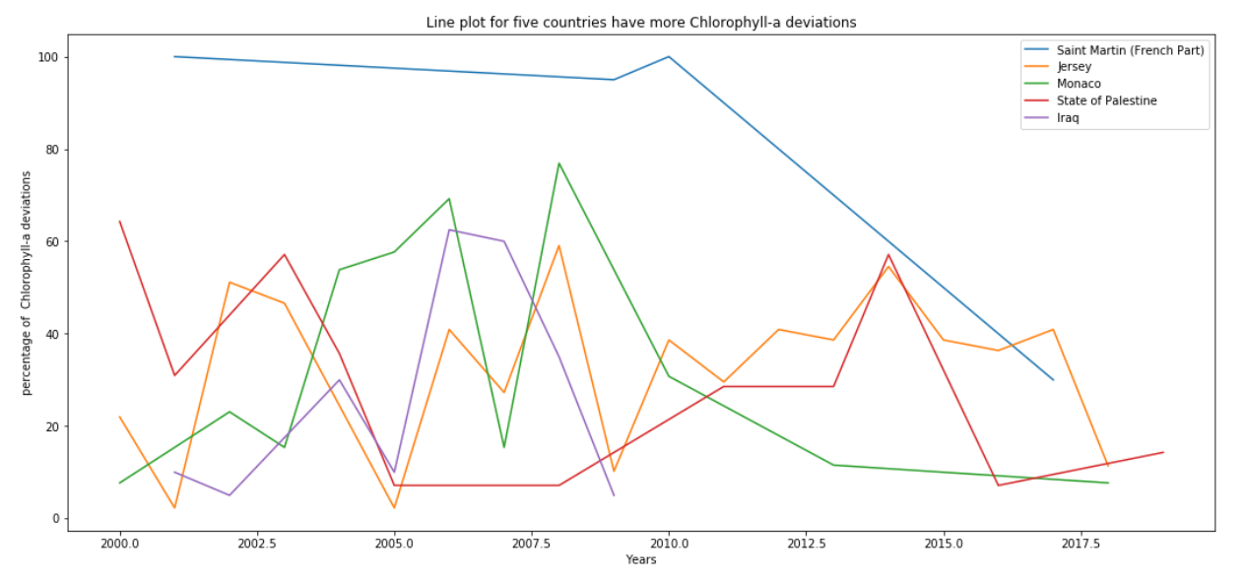

From a fixed year and time varying plot we can observe that for country saint Martin the deviation is maximum in 2010 and then gradually decreases and reaches it minimum in 2017 but that is the maximum deviation for other top most chlorophyll deviation countries. Therefore we can tell that the above five continents are the major supporters to preserve the Oceans to their respective continent.

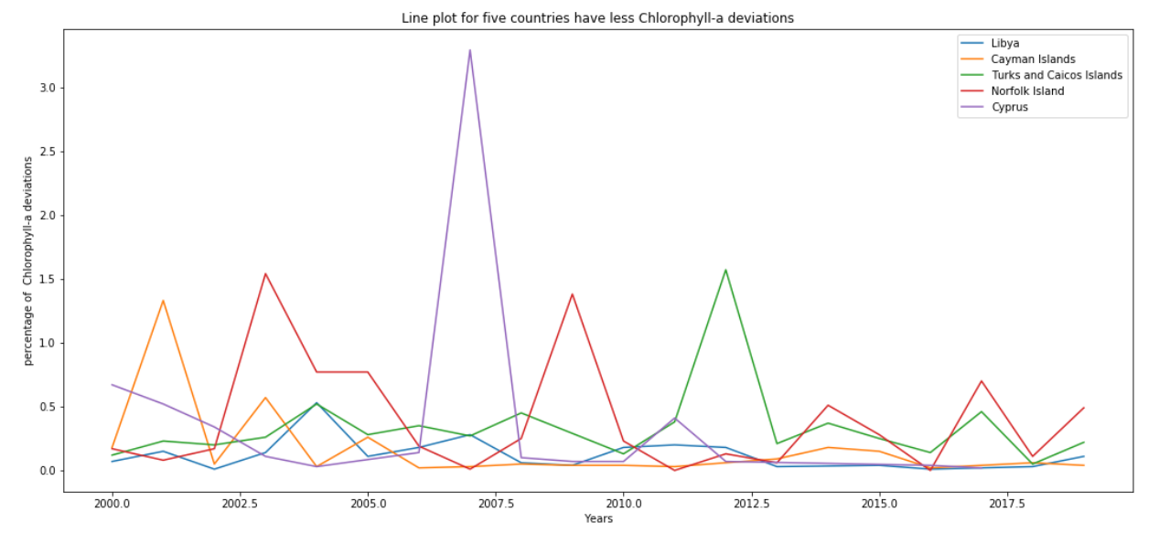

From the plot we can infer that Cyprus had maximum deviation among the less chlorophyll-a deviation countries.

1. **Time fixed and space varying**

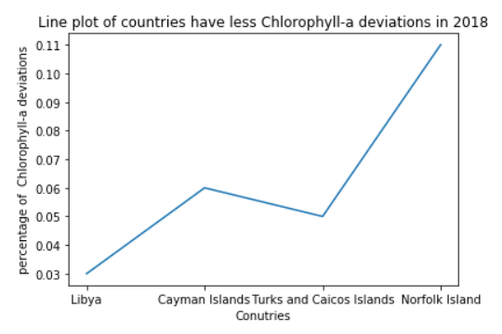

In 2018 Norfolk Island had maximum deviation among less chlorophyll-a deviation. Libya had the lowest deviation among all the countries.

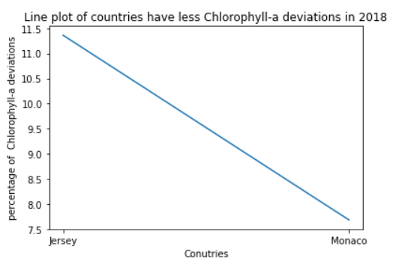

Jersey had the maximum percentage of deviation in 2018. Jersey’s contribution to the global % of chlorophyll deviation is higher than the other continents.

**Continent wise analysis of Chlorophyll Deviation**

**Barplot for the Values of the continents of Chlorophyll Deviation**

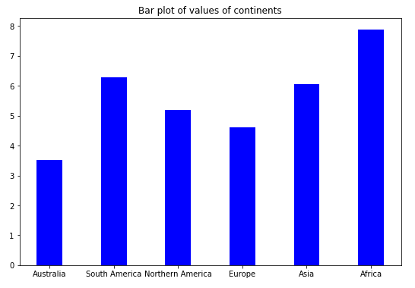

Africa has the maximum percentage of deviation among all the continents, South America and Asia have the next highest percentage of deviation. Africa’s contribution to the global % of chlorophyll deviation is higher than the other continents.

## **Time Series Analysis for continents**

* **Lag Plot of continents for indicator Chlorophyll Deviation**

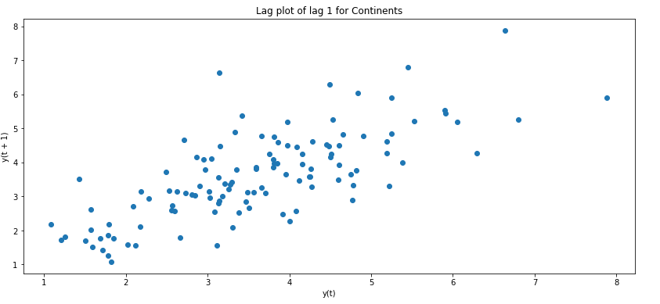

The above graph is a lag plot for lag1 for continents. Lag 1 for continents is uncorrelated that is, the chlorophyll deviation of continents is correlated itself with lag 1.

* **Autocorrelation Plot of continents for indicator Chlorophyll Deviation**

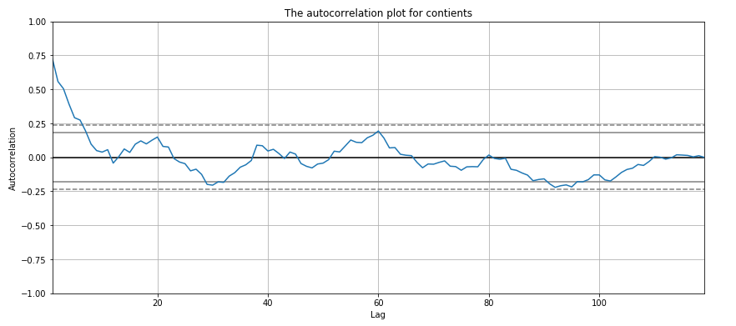

The correlation for all lags lies between the threshold line which indicates the no autocorrelation for continents.

**Trend & seasonal plot**

* **Seasonal plot for Asia**

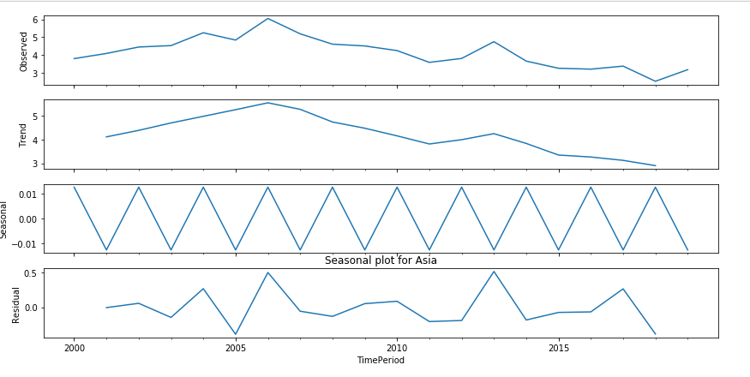

From the trend plot, we can infer that the trend of the Chlorophyll deviation of Asia is decreasing over the years. From the seasonal plot, we can see that there is a pattern every two years. That is in 2001, the Chlorophyll deviation of Asia was decreasing and again it was increasing in next year likewise the seasonality goes on

* **Seasonal plot for Australia**

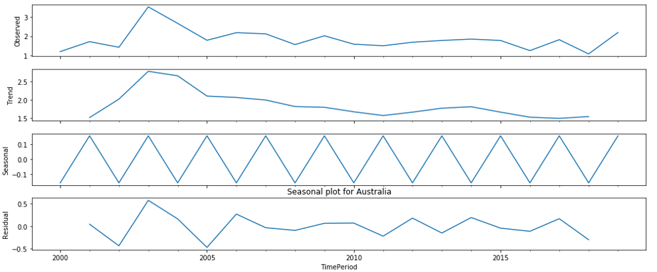

From the trend plot, we can infer that the trend of the Chlorophyll deviation of Australia is decreasing over the years. From the seasonal plot, we can see that there is a pattern every two years. That is in 2001, the Chlorophyll deviation of Australia was increasing and again it was increasing in next year likewise the seasonality goes on.

* **Seasonal plot for Europe**

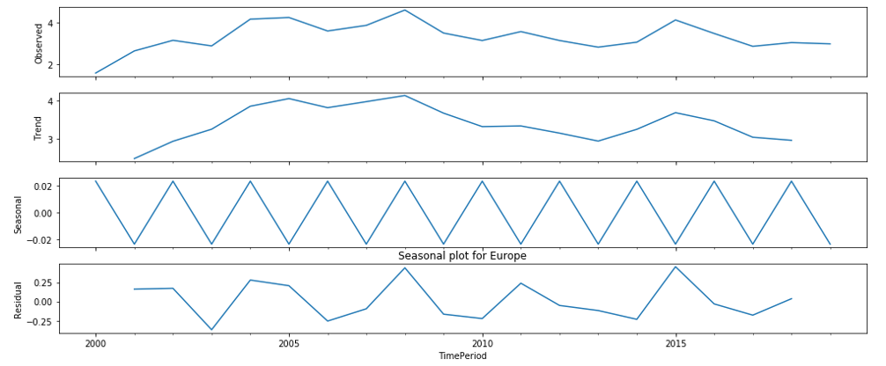

From the trend plot, we can infer that the trend of the Chlorophyll deviation of Europe is decreasing over the years. From the seasonal plot, we can see that there is a pattern every two years. That is from 2000 to 2001, the Chlorophyll deviation of Europe was decreasing and again it was increasing in next year likewise the seasonality goes on.

* **Seasonal plot for North America**

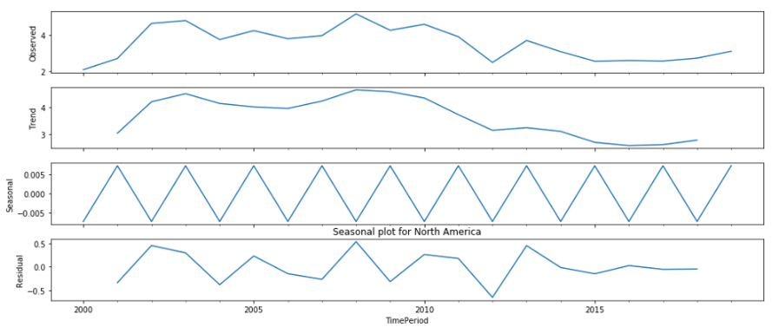

From the trend plot, we can infer that the trend of the Chlorophyll deviation of North America is decreasing over the years. From the seasonal plot, we can see that there is a pattern every two years. That is from 2000 to 2001, the Chlorophyll deviation of North America was increasing and again it was decreasing in next year likewise the seasonality goes on

* **Seasonal plot for South America**

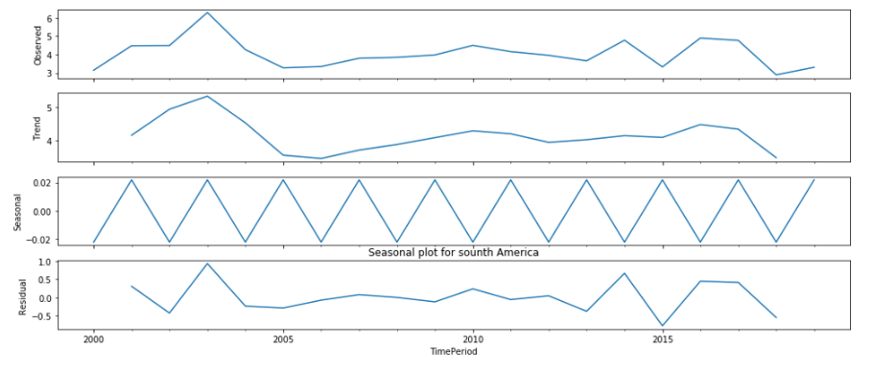

From the trend plot, we can infer that the trend of the Chlorophyll deviation of South America is decreasing over the years. From the seasonal plot, we can see that there is a pattern every two years. That is from 2000 to 2001, the Chlorophyll deviation of South America was increasing and again it was decreasing in next year likewise the seasonality goes on.

**Spatio Temporal Analysis**

**a) space fixed and time varying**

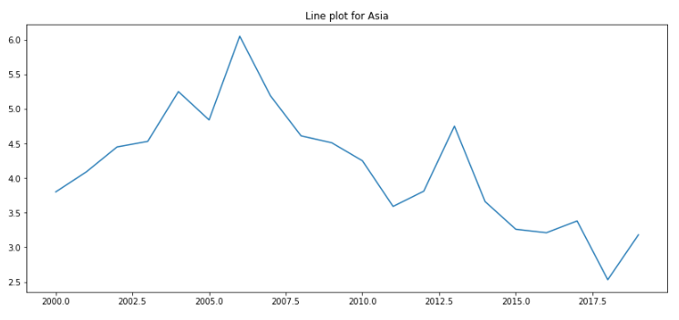

Asia’s percentage of chlorophyll deviation declined in 2018. This is not following any pattern at random it attains its minimum and maximum % of chlorophyll deviation.

**b) Both time and space varying**

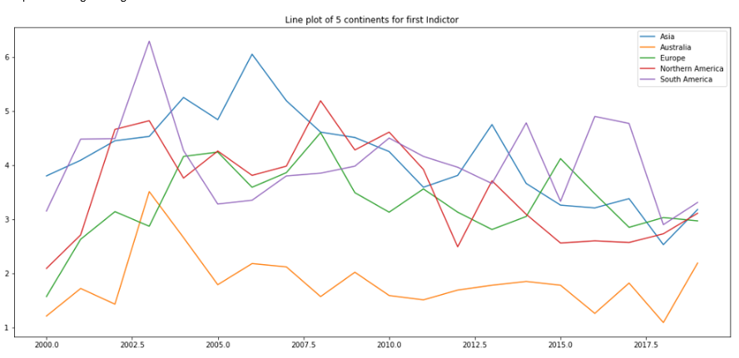

Australia’s chlorophyll deviation is minimum in all the year and other continents not following any pattern.

**c)Time fixed(2018) and space varying**

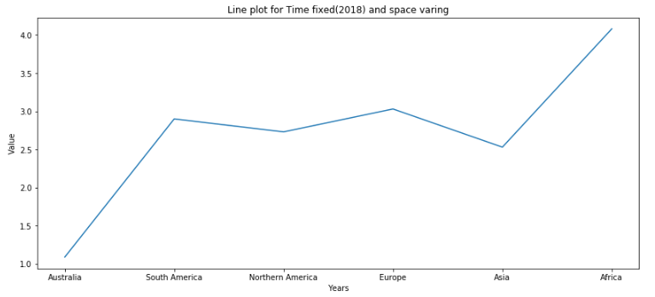Africa's Chlorophyll deviation is maximum in 2018 which contributed maximum to the global in 2018.

**Analysis for Indicator 14.5.1- proportion of Marine Key Biodiversity Areas (KBAs) covered by protected areas (%)'**

**Dataframe for Indicator 14.5.1**

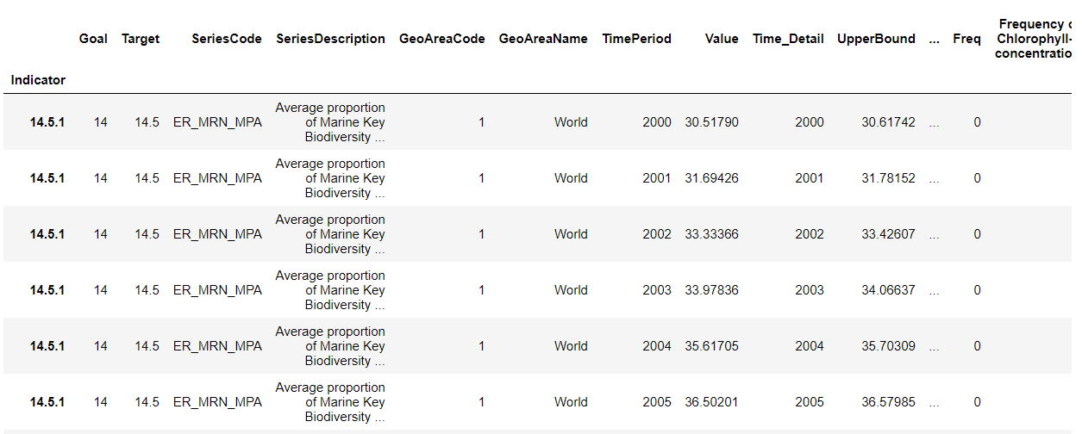

**Average proportion of each country**

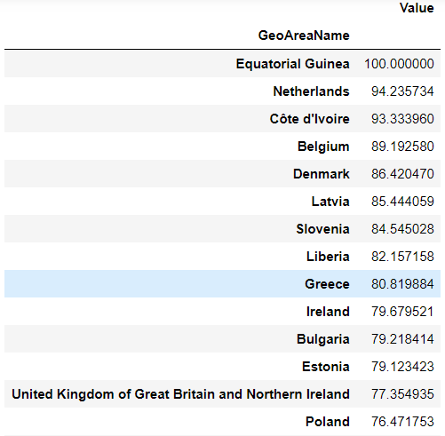

The top five countries for average proportion of Marine Key Biodiversity Areas **'Equatorial Guinea', 'Netherlands','Côte d'Ivoire', 'Denmark','Belgium '**

The last 5 countries for average proportion of Marine Key Biodiversity Areas **'Montenegro','Benin','Grenada','Papua New Guinea','Solomon Islands'**

**Pivot table for KBAs**

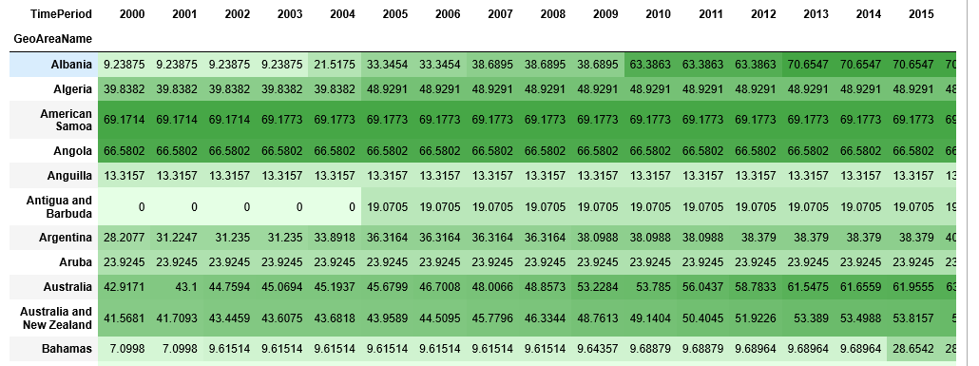

The dark green cells show the highest percentage of KBAs covered by the protected Area. Light color cells have the lowest percentage of KBAs covered by the protected Area.

**PIVOT table for average proportion of each country in every year**

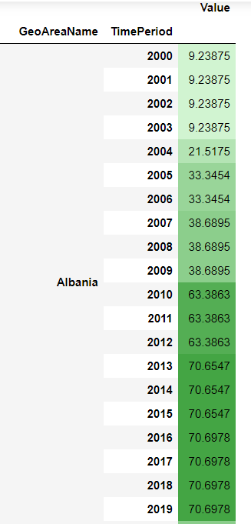

**Spatio temporal Analysis for best and worst countries:**

1. **Space fixed and time varying**

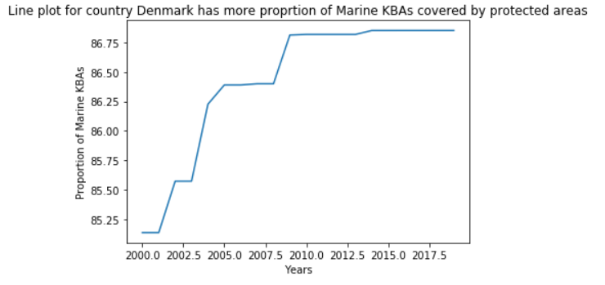

The highest KBAs covered by protected area of Denmark in 2010 from that till 2017 proportion of KBAs covered by protected area is constant .

1. **Both time and space varying**

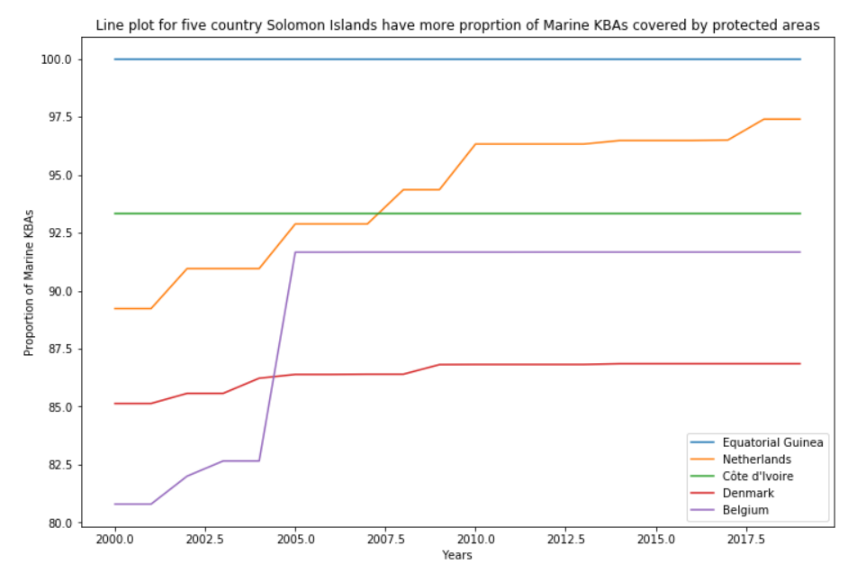

The maximum KBAs covered by the protected area of Equatorial Guinea is 100 which maintains the same value from 2000 to 2018 and cote d'ivoire also maintains the same value from 2000 to 2018. Other countries had slight changes between 2000 to 2005 then those countries maintained the same proportion after 2005.

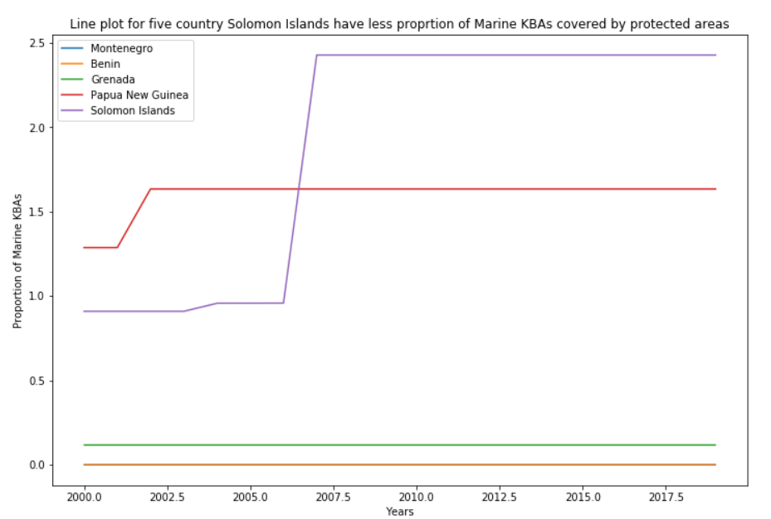

The last five countries which have the least proportion of KBAs covered by protected areas also maintain the same proportion from 2006 to 2018.

1. **Time fixed space varying**

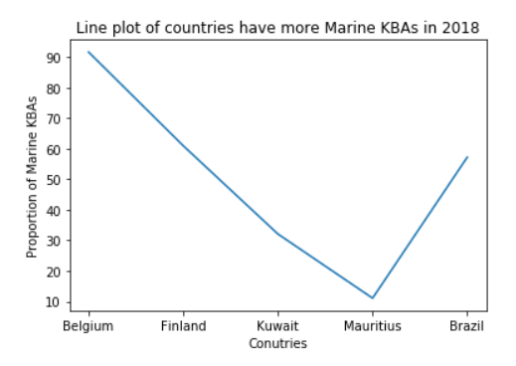

In year 2018 proportion of kBAs covered by protected areas is maximum for Belgium and minimum in Mauritius in 2018

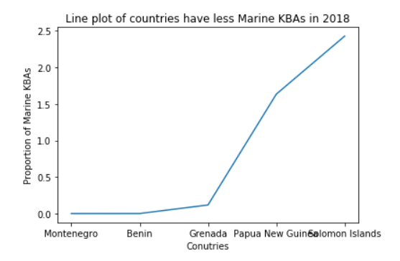

Among the least proportion of kBAs covered by protected countries Montenegro and Benin is the least among all countries..

**Continent wise analysis of KBAs**

**Barplot for the Values of the continents of Beach Litter Indicator**

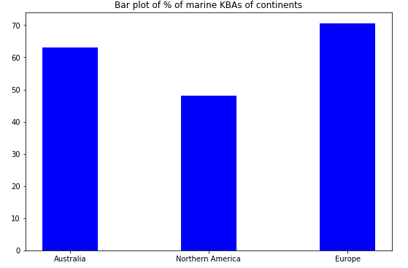

Continent Europe the proportion of kBAs covered by protected areas is maximum than Australia and North America.

**Time Series Analysis for continents**

* **Lag Plot of continents for indicator KBAs**

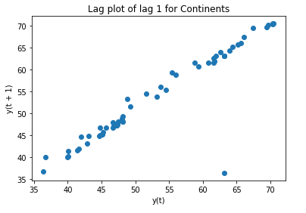

The above graph is a lag plot for lag1 for continents. Lag 1 for continents is uncorrelated that is, the beach litter of continents is correlated itself with lag 1.

* **Autocorrelation Plot of continents for indicator beach litter**

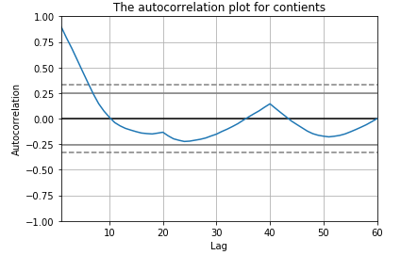

The correlation for all lags lies between the threshold line except lag1 which indicates the no autocorrelation for continents.

**Trend & seasonal plot**

* **Australia**

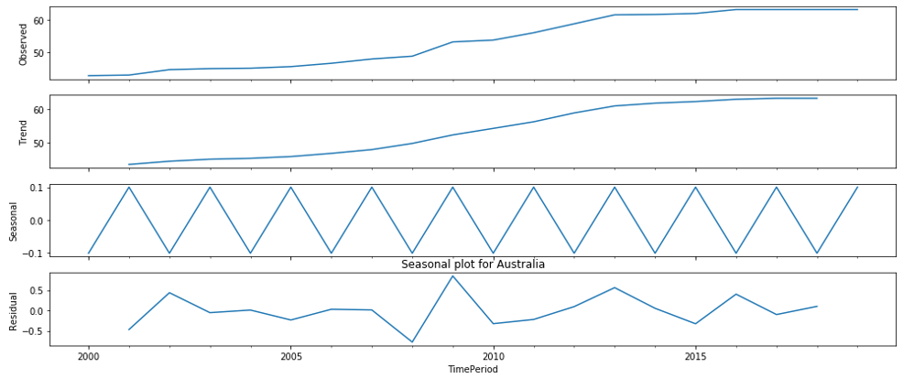

From the trend plot, we can infer that the trend of the KBAs covered by the area of Australia is increasing over the years. From the seasonal plot, we can see that there is a pattern every two years. That is from 2000 to 2001, the KBAs covered by the area of Australia was increasing and again it was decreasing in next year likewise the seasonality goes on.

* **Europe**

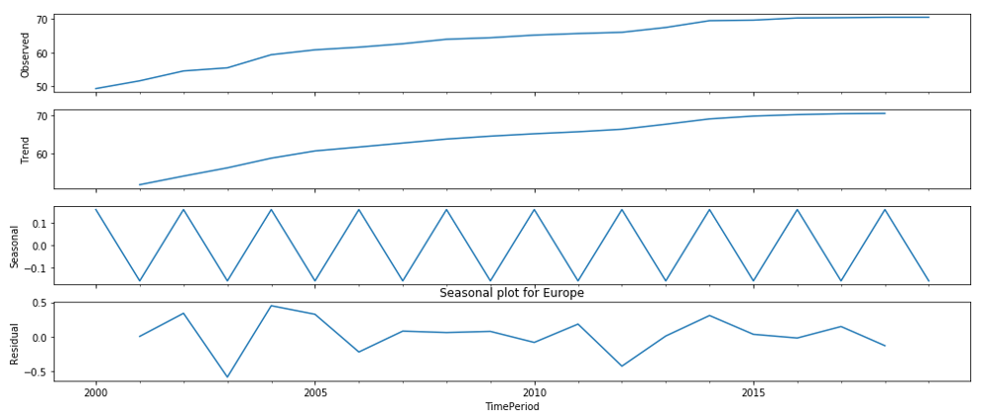

From the trend plot, we can infer that the trend of the KBAs covered by the area of Europe is increasing over the years. From the seasonal plot, we can see that there is a pattern every two years. That is from 2000 to 2001, the KBAs covered by the area of Europe was decreasing and again it was increasing in next year likewise the seasonality goes on.

* **North America**

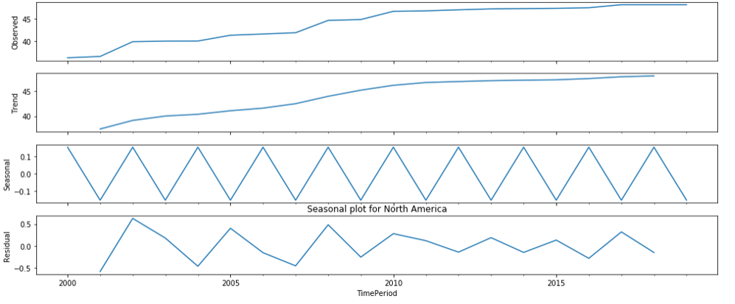

From the trend plot, we can infer that the trend of the KBAs covered by the area of North America is increasing over the years. From the seasonal plot, we can see that there is a pattern every two years. That is from 2000 to 2001, the KBAs covered by the area of North America was decreasing and again it was increasing in next year likewise the seasonality goes on.

## **Spatio Temporal Analysis for continents:**

**a) space fixed and time varying**

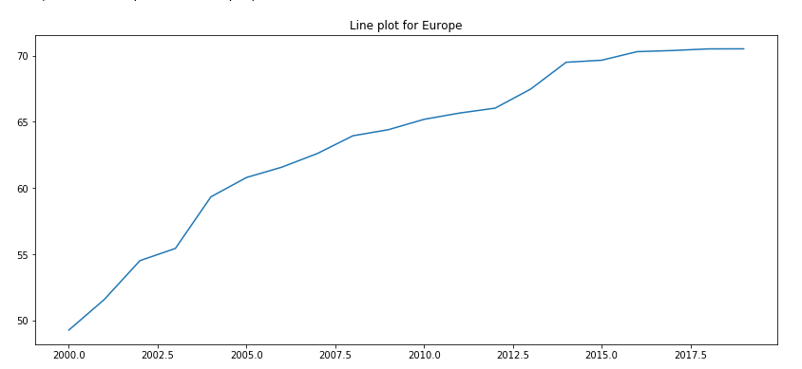

The proportion of kBAs covered by protected areas of Europe increases over a year that is following an increasing trend.

**b)Both Space Time and Space Varying**

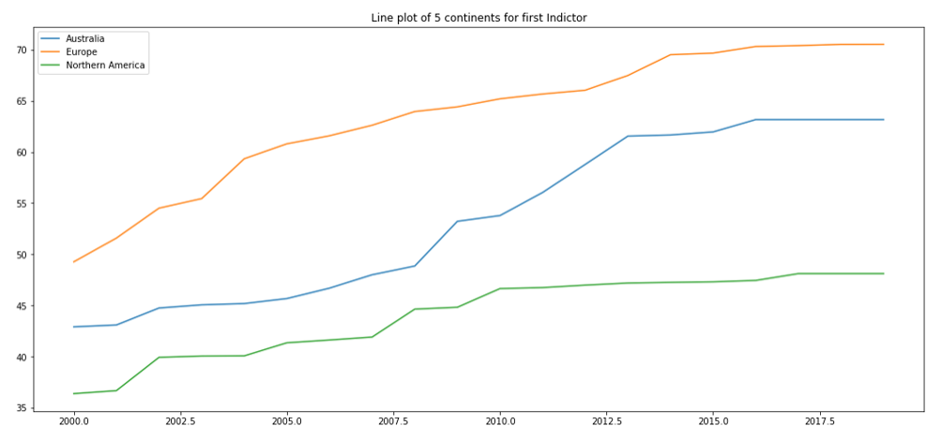

The proportion of kBAs covered by protected areas of Australia, Europe and North America increases over a year that is following an increasing trend. Among these countries the proportion of kBAs covered by protected areas is maximum for Australia.

**c) Time fixed and Space varying**

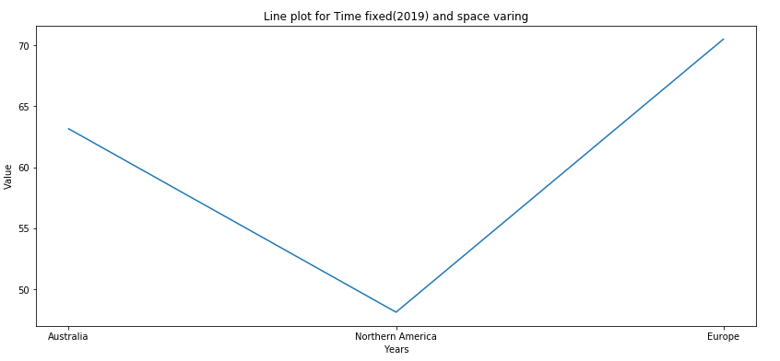

In 2019 proportion of kBAs covered by protected areas is maximum for Europe and minimum is North America in 2019. Europe's contribution to the global proportion of kBAs covered by protected areas is maximum in 2019.

**Analysis for Indicator 14.a.1- National ocean science expenditure as a share of total research and development funding (%)**

The target 14.a is **Increase scientific knowledge, research and technology for ocean health** which is progressed by the percentage of share of total research and development funding for national ocean science expenditure. If this percentage is high then that indicates the good sign for this target.

**Dataframe for Indicator 14.a.1**

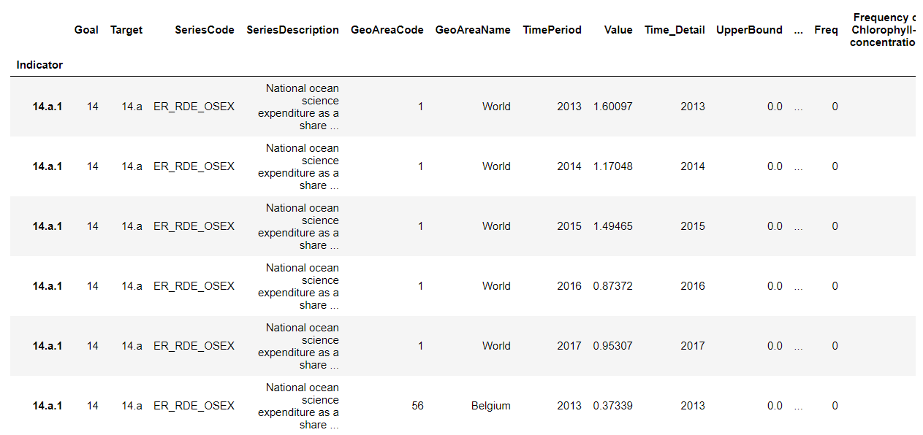

**Average expenditure for ocean science for each country**

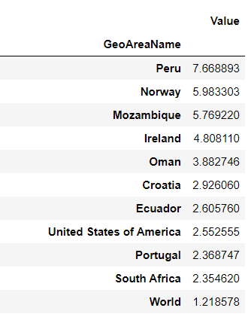

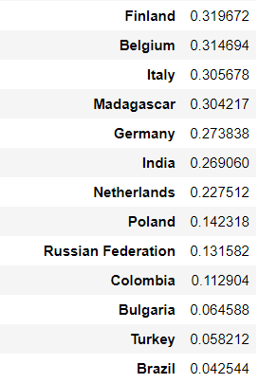

From the table, the best and worst countries for the expenditure of ocean science have been found. **The top five countries having high expenditure of ocean science are ‘Peru', 'Mozambique', 'Norway', 'Ireland', 'Oman'. The bottom five countries having less expenditure of ocean science are 'Bulgaria','Russian Federation',"Turkey","Colombia",”Brazil”**

**Bar plot of the average value of Ocean science expenditure of each countries**

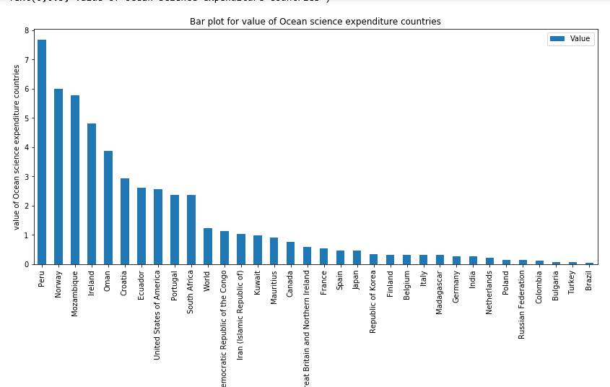

The top 5 countries for target oceans science expenditure are 'Russian Federation', 'Colombia','Bulgaria', 'Turkey','Brazil'

The last 5 countries for target oceans science expenditure 'Peru', 'Mozambique', 'Norway',' Ireland', 'Oman'

**Spatio temporal analysis for best and worst countries**

**a) Space fixed time varying**

* **Line plot for the country Norway of ocean’s science expenditure more**

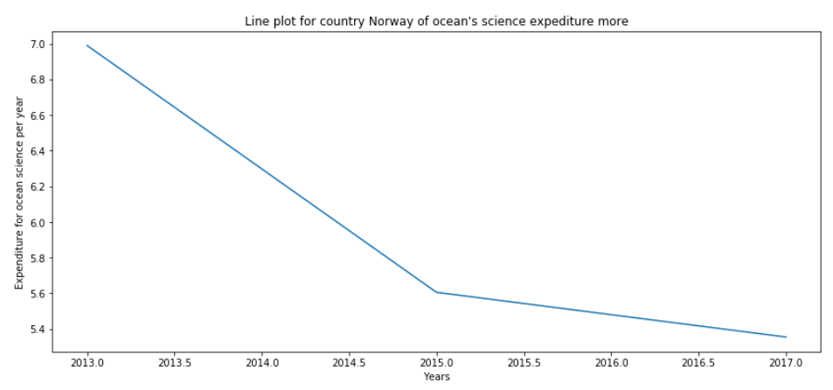

The percentage of expenditure for ocean science of Norway is high in 2013 then it’s slowly decreases over the time

* **Line plot for the country Norway of ocean’s science expenditure less**

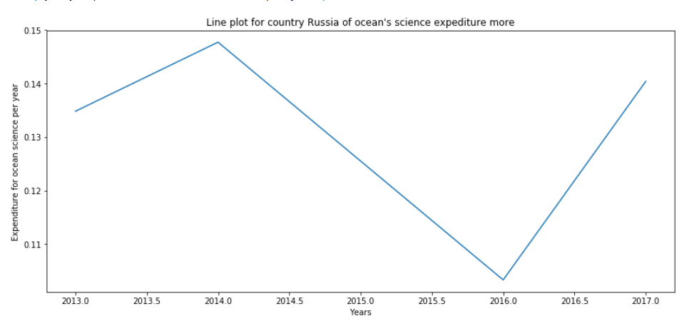

The graph shows that the expenditure for ocean science of Russia is initially increased in the period of 2013-14. But after 2014, it drastically decreased in 2016. After that again they improved.

**b) both time and space varying**

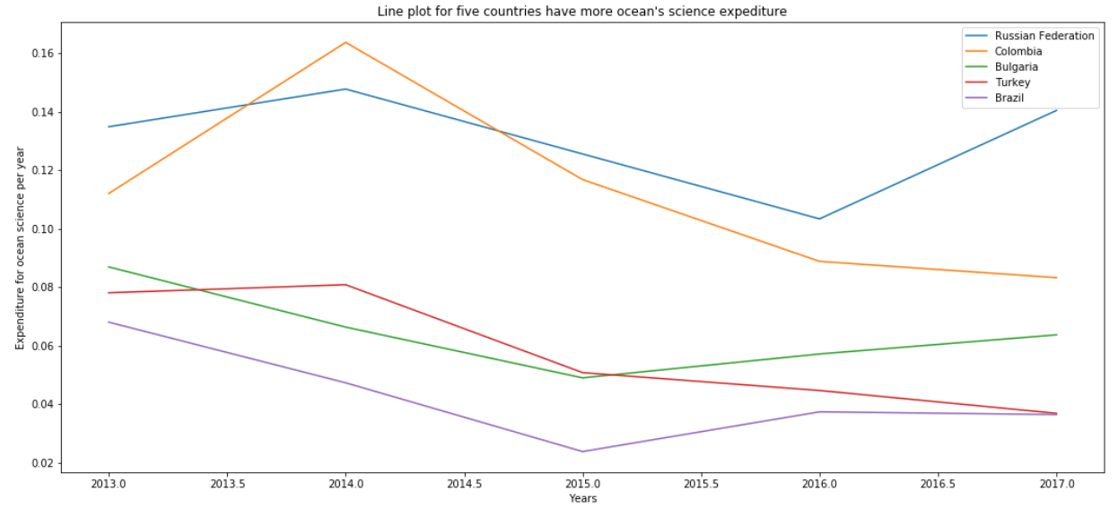

Among these five countries, Colombia has high expenditure for ocean science. Mostly all the countries following same pattern

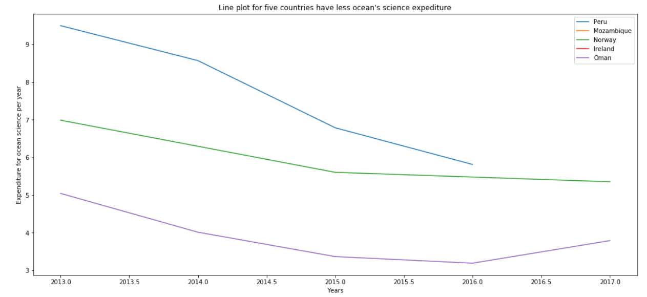

All three countries’ ocean science expenditures are decreasing over time. Among three countries, Peru has high expenditure for ocean science.

**c)Time fixed and space varying**

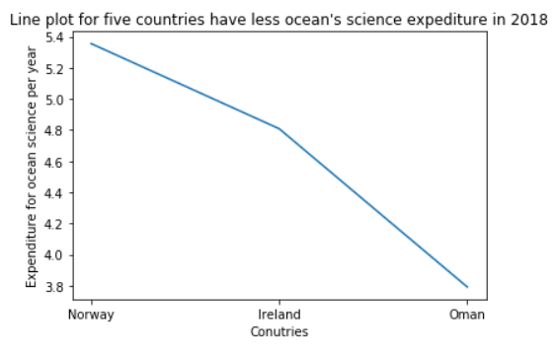

The graph shows that the ocean science expenditure of Norway is higher than others.

**Time series Analysis:**

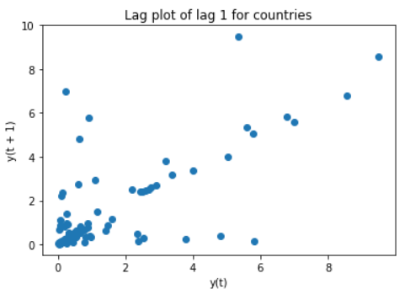

The above graph is a lag plot for lag1 for continents. Lag 1 for continents is uncorrelated i.e) the beach litter of continents are correlated itself with lag 1.

* **Autocorrelation:**

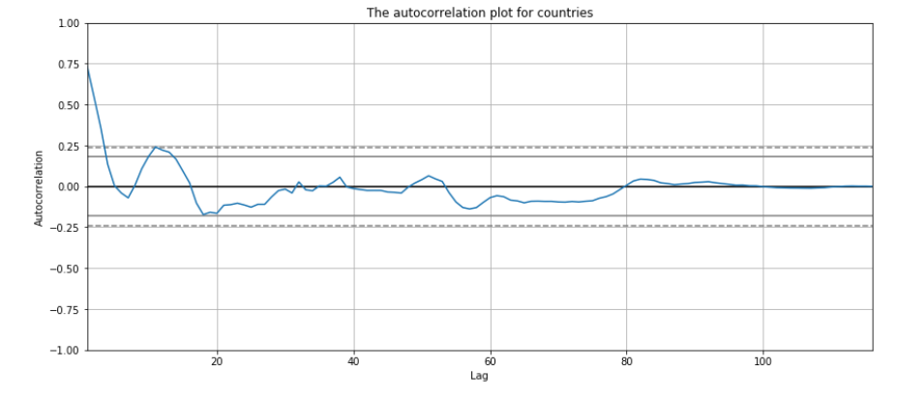

The correlation for all lags lies between the threshold line which indicates the no autocorrelation for countries.

* **Trend and seasonal plot for Peru**

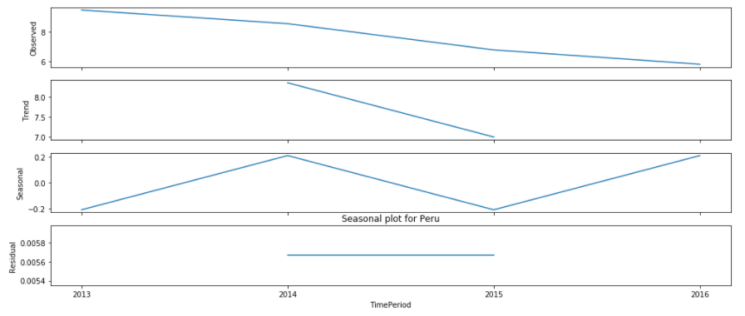

From the trend plot, we can infer that the trend of the expenditure of the Ocean’s since and development funding of Peru is decreasing over the years. From the seasonal plot, we can see that there is a pattern every two years. That is from 2013 to 2014, the Ocean’s since and development funding of Peru was increasing and again it was decreasing in next year likewise the seasonality goes on.

* **Trend and seasonal plot for Brazil**

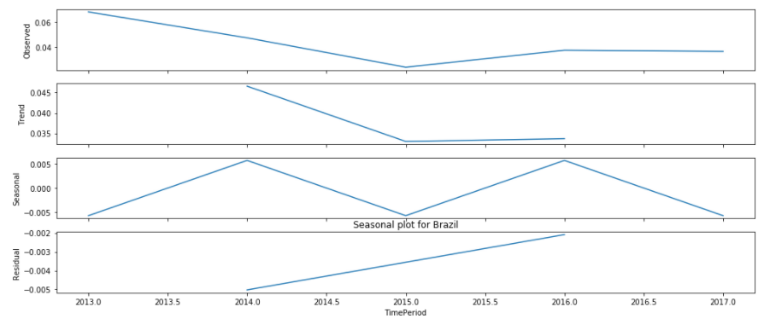

From the trend plot, we can infer that the trend of the expenditure of the Ocean’s since and development funding of Brazil is decreasing over the years. From the seasonal plot, we can see that there is a pattern every two years. That is from 2013 to 2014, the Ocean’s since and development funding of Brazil was increasing and again it was decreasing in next year likewise the seasonality goes on.

**Analysis of India and world with different Indicators**

Here, we are going to analyse the india and world data for chosen indicators and aimed to compare the india with world data.

**Dataframe of India for all chosen indicators:**

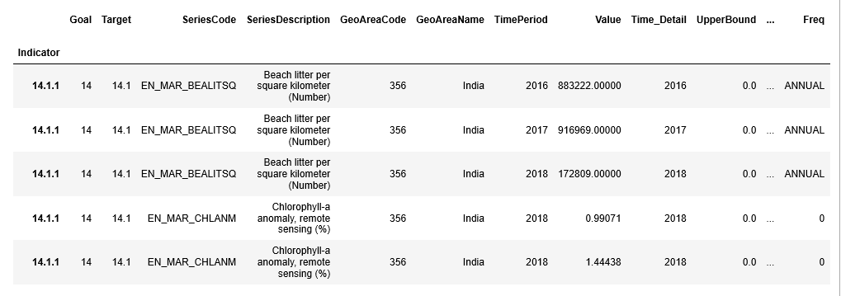

**Pivot table for values of different indicators for each year:**

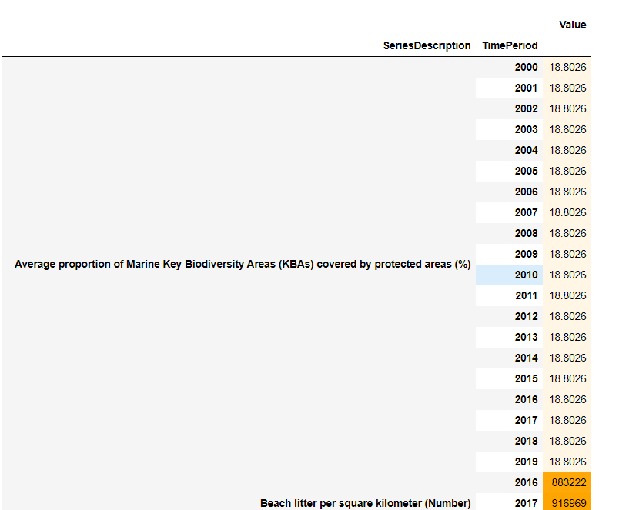

From the above pivot table, we can infer that the values of the average proportion of marine KBAs for India is the same for every year. The dark color indicates the high value and light color indicates the low value.

**Comparing India with World level for each indicator:**

**Beach litter Indicator:**

* **bar plot of India for beach litter**

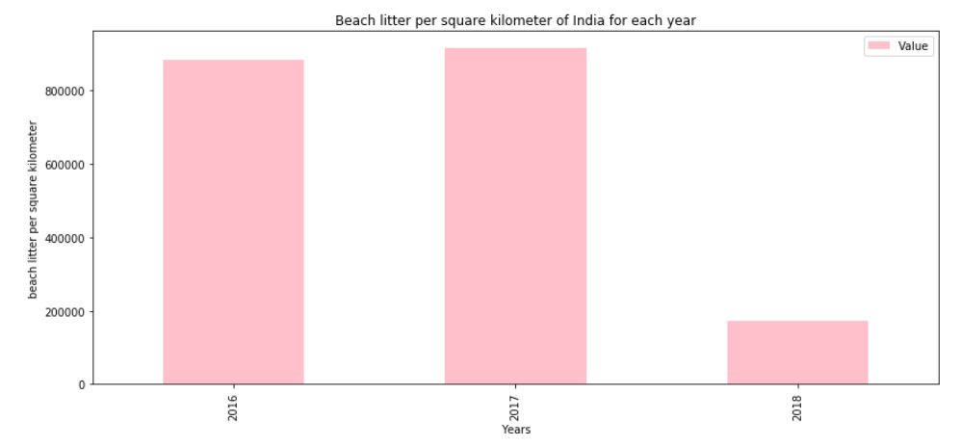

The graph shows that the beach litter per square kilometer of India was high in 2016 and 17 but it was very low in the next year 2018 which tells that the government took measures to reduce the garbage in the ocean.

* **Line plot of India for beach litter**

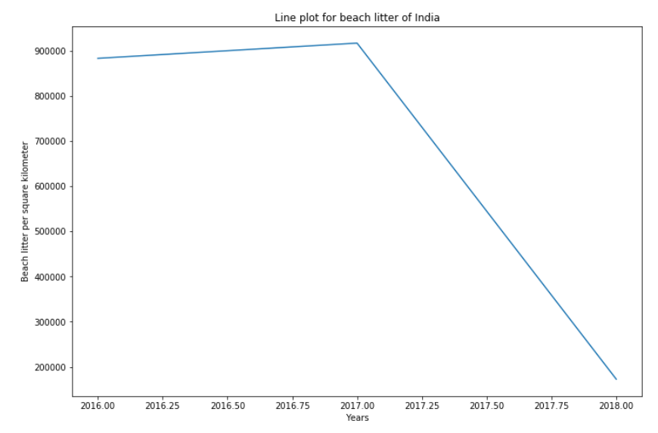

The above graph shows that the beach litter of India is decreasing over the time which is a good indication and also tells that they took remedial measures to reduce marine pollution.

* **bar plot of World for beach litter**

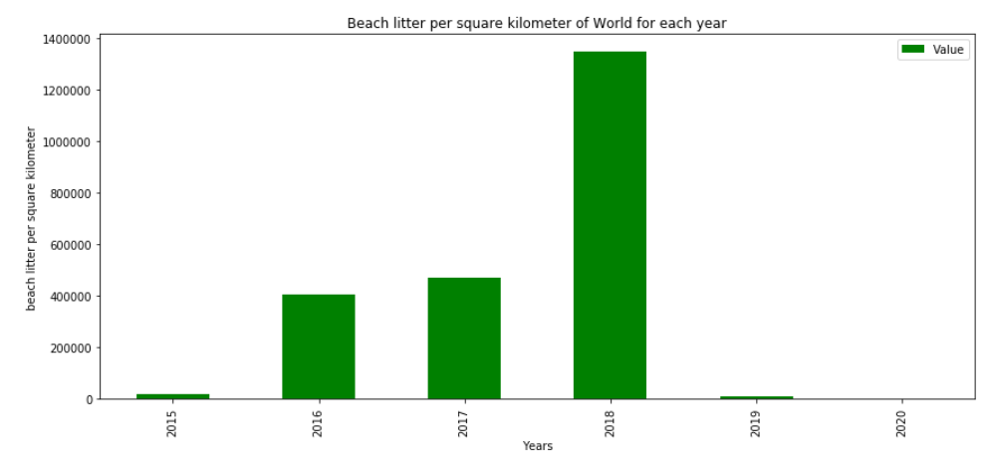

In 2018, beach litter in the overall world is very high in 2018 but in next year itself reduced the beach litter which is a positive indication. **The all over countries took measures to reduce marine pollution. From this, we also infer that the first target which is to reduce marine pollution may be achieved before 2030.**

* **Line plot of World for beach litter**

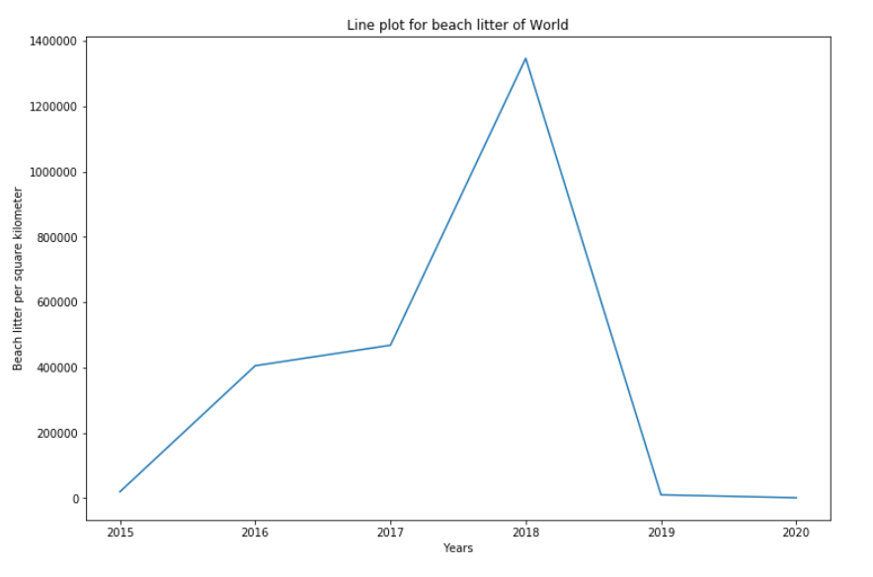

**The above graph shows that the beach litter of the overall world was increased in the period of 2015 -2018 then started to decline in next year 2019** which is a good indication and also tells that they took remedial measures to reduce marine pollution.

* **Comparison plots of India and World for Beach litter Indicator**

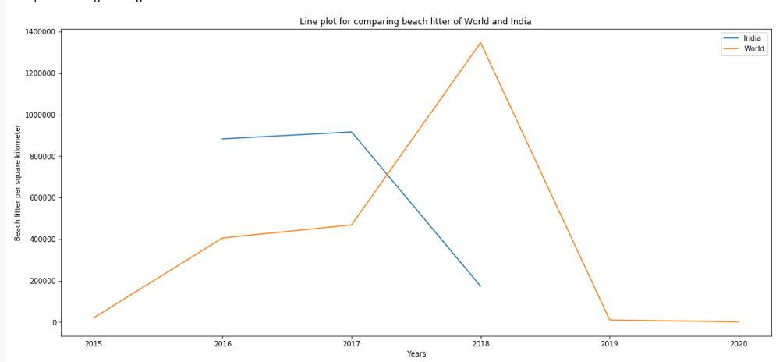

From the graph, we can clearly see that In the period of 2016-18, the beach litter of the world was increased from lowest value but In india, the bitter litter of india was decreased from highest value. After 2018, the world's beach litter decreased.

* **Bar plot for beach litter of India and world**

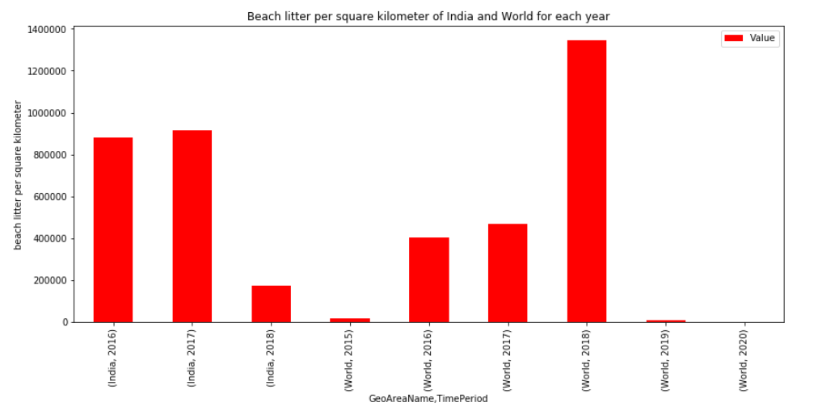

The graph shows that the highest beach litter in the world was estimated in 2018 but in the same time the beach litter value of India was very less. So from this, we can infer that some countries contributed more beach litter to the overall world ocean.

**Time series analysis of world for beach litter indicator**

* **Autocorrelation Plot**

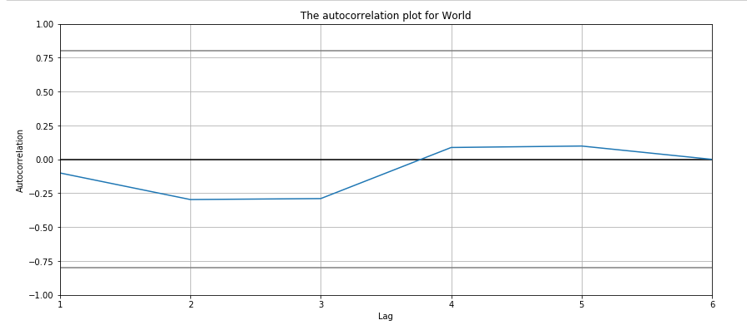

The correlation for all lags lies between the threshold line which indicates the no autocorrelation for the beach litter of the world.

* **Seasonal and Trend plot for beach litter of world**

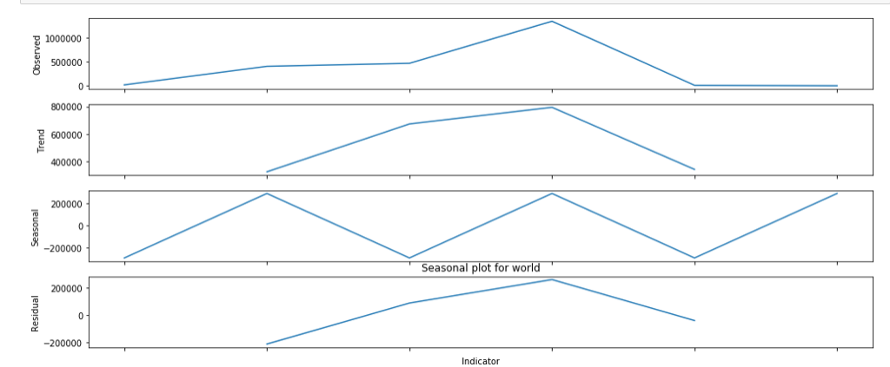

From the trend plot, we can infer that the trend of the marine debris of Peru is decreasing over the years. From the seasonal plot, we can see that there is a pattern every two years. That is from 2000 to 2001of the marine debris of Peru was increasing and again it was decreasing in next year likewise the seasonality goes on.

**Prediction for beach litter of world by Rolling mean**

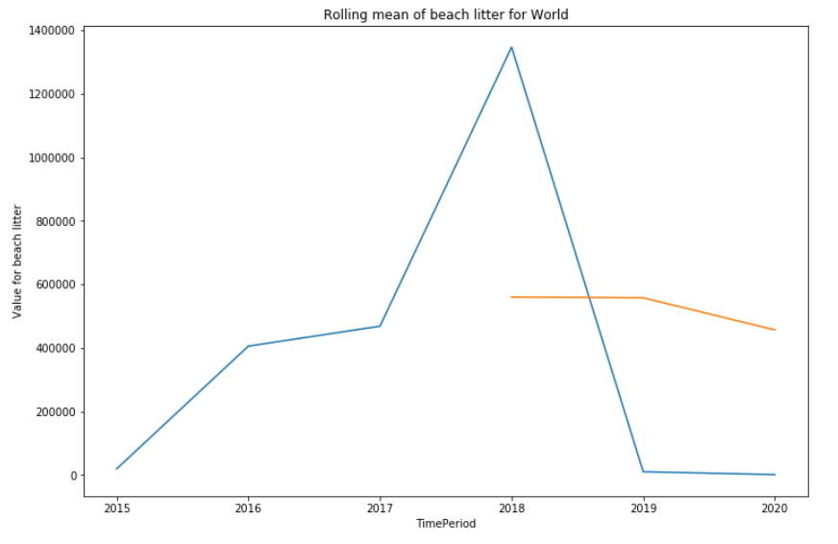

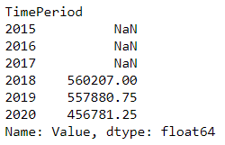

Blue line denotes Beach litter per square kilometer of the world and orange represents the Average Beach litter per square kilometer of the world . The predicted average proportion of Marine key Biodiversity Area covered by protected area(%) for 2019 approximately be 456781.25.

**Indicator 14.5.1 - average proportion of biodiversity key areas**

* **Line plot for average proportion of biodiversity areas of India**

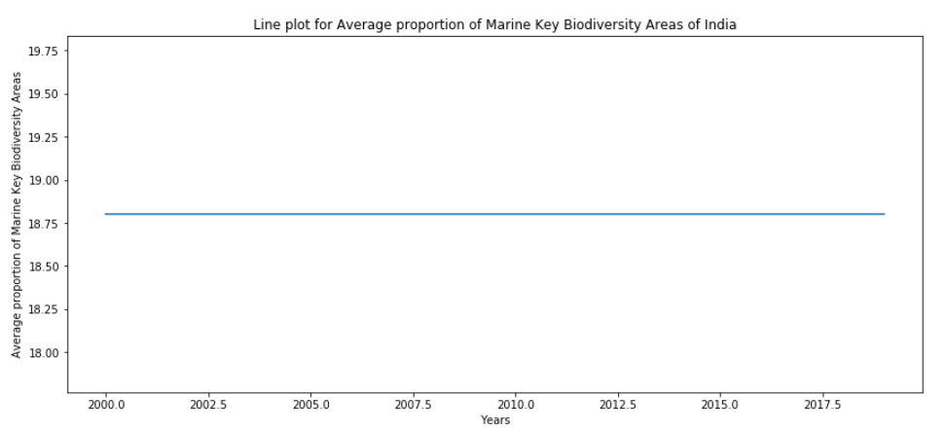

The graph shows that the average proportion of biodiversity key areas of India is the same in all the years.

* **bar plot for average proportion of biodiversity areas of India**

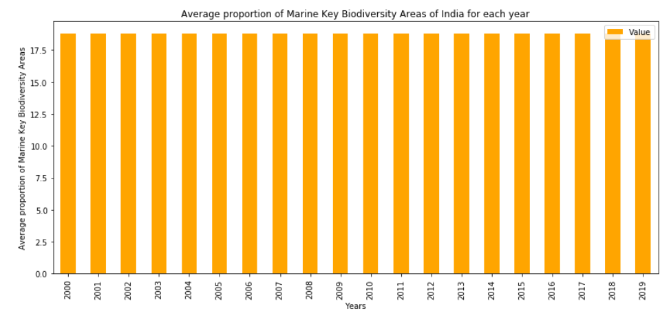

The graph shows that the average proportion of biodiversity key areas is the same throughout all the years.

* **Line plot for average proportion of biodiversity areas of world**

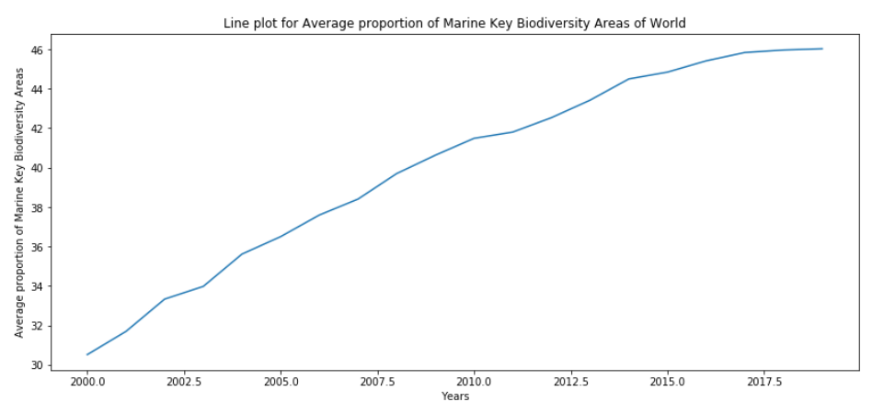

The graph shows that the average proportion of biodiversity areas of the overall world is gradually increasing over the years which is a good indication.

* **Bar plot for average proportion of biodiversity areas of world**

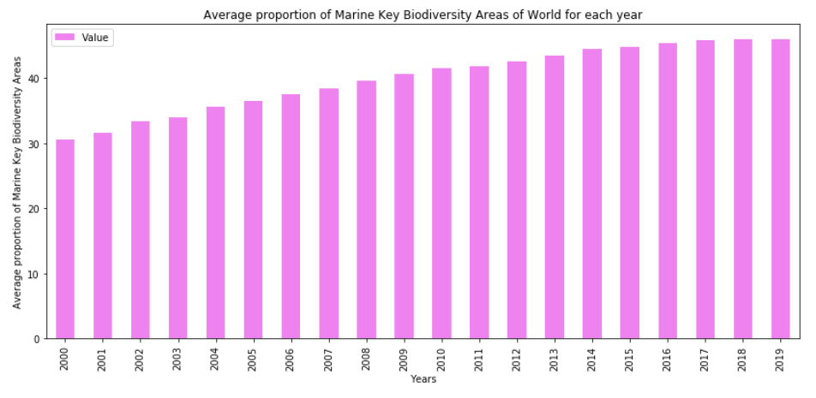

The graph shows that the average proportion of biodiversity areas of the overall world is gradually increasing over the years which is a good indication.

**Comparison plots of India and World for average proportion of biodiversity areas**

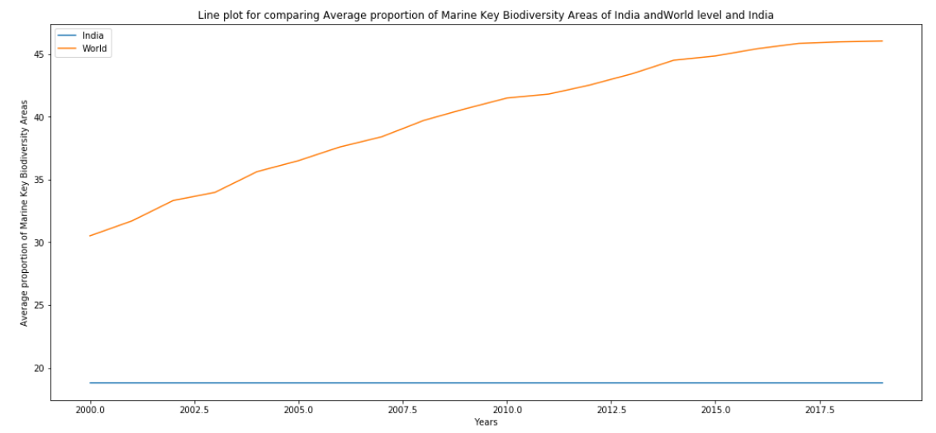

From the comparison plot, we can see that the average proportion of biodiversity areas of India is the same for all years and also very less than the world average.

**Time Series Analysis for average proportion of biodiversity areas of world:**

* **Autocorrelation**

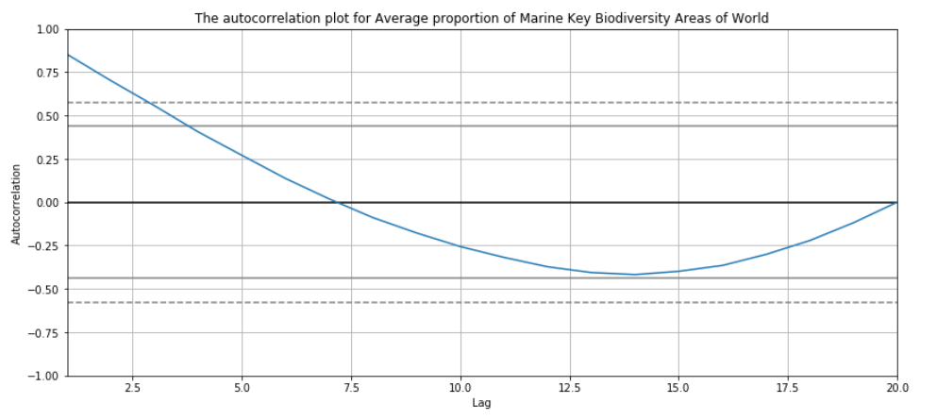

The correlation for all lags lies between the threshold line which indicates the no autocorrelation for the average proportion of biodiversity areas of the world.

**Trend and Seasonal plot for average proportion of biodiversity areas of world**

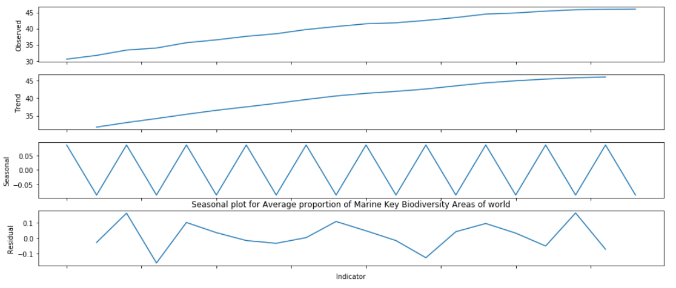

From the trend plot, we can infer that the trend of the Average proportion of marine key biodiversoty of the world is increasing over the years. From the seasonal plot, we can see that there is a pattern every two years. That is from 2000 to 2001of the Average proportion of marine key biodiversoty of the world was increasing and again it was decreasing in next year likewise the seasonality goes on.

**Prediction for average proportion of biodiversity areas of world by Rolling mean**

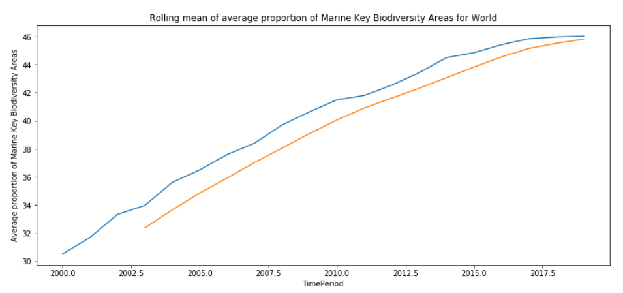

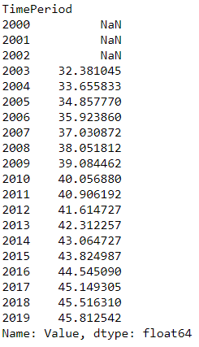

Blue line denotes the Marine key biodiversity areas of the world and orange represents the moving average Marine key biodiversity areas for the world . Here the data was given for till 2018. The predicted average proportion of Marine key Biodiversity Area covered by protected area(%) for 2019 approximately be 45.812542.

**Discussion:**

We have analysed the data set Goal14 which contains 10 Targets and 15 Indicators. In this 10 we have selected

* target 1 (**Reduce Marine Pollution**)
* target 3 (**Reduce Ocean Acidification)**
* target 5(**Conserve Coastal and Marine Area)**
* target 14a **(Increase scientific knowledge, research and technology for Ocean health).**

No data is available for target2 so we have deleted that. Target 4, Target 6, Target 14b have no sufficient data to analyse most observations are missing so we have removed those targets for analysis.

**Target1:**( **Reduce Marine Pollution**)

* Target 1 is analysed by two indicator Beach litter per square kilometer and Chlorophyll-a deviation. We have analysed top 5 countries which have the maximum marine debris and which have the least marine debris also performed the spatio temporal analysis for these top5 and bottom5 countries by keeping the space fixed and time varying, Time fixed and space varying and Both varying. The best and worst countries of polluting oceans have been found. **The top five countries polluting the ocean more are 'Belgium', 'Finland', 'Kuwait', 'Mauritius', 'Brazil'. The bottom five countries polluting the ocean less are 'Netherlands', 'Kenya',' Philippines', 'Mexico', 'Italy'**. From this analysis we inferred that Beach litter per square kilometer (Number) value is increasing, as the year increases for the country Ghana. That is the garbage in the Oceans is increasing day by day in Ghana. South America's contribution to the global marine debris in 2015 had been so high such that its contribution to the same in 2016 which was intensely controlled and much reduced, was still higher than the other continents. When we analyse by continent wise in all the year South America’s marine debris is maximum.
* From the table, the best and worst countries for average chlorophyll-a deviation have been found. The top five countries having high chlorophyll deviation in the ocean are 'Saint Martin (French Part)', 'Jersey','Monaco', 'State of Palestine','Iraq'. The bottom five countries having less chlorophyll deviation are 'Libya','Cayman Islands','Turks and Caicos Islands','Norfolk Island','Cyprus’. Jersey had the maximum percentage of deviation in 2018. Jersey’s contribution to the global % of chlorophyll deviation is higher than the other continents. Africa has the maximum percentage of deviation among all the continents, South America and Asia have the next highest percentage of deviation. Africa’s contribution to the global % of chlorophyll deviation is higher than the other continents.

**Target3**

* Target3 is analysed using the indicator Average of marine acidit. The best and worst countries for average marine acidity have been found. The top five countries which have more marine acidity are 'Belgium', 'Finland','Kuwait', 'Mauritius', 'Brazil'. The bottom five countries which have less marine acidity are 'Netherlands','Kenya','Philippines','Mexico','Italy'. pH of the ocean in Belgium has drastically increased in 2012-13. The pH of the ocean in Brazil is higher than other countries till 2016. The pH of the ocean in Brazil is high only but it’s decreasing over time which is not a good sign. pH of the ocean in philippines in 2015 is very low but in 2017 the pH level is increasing more which tells that they took the measures to reduce the carbon dioxide in the atmosphere which is a positive indication. But other countries' pH is decreasing over time. The Continent data is not available for this indicator except Australia. **In 2010, the pH of the ocean in Australia was high but it decreased over time which tells that the carbon dioxide was increasing in the atmosphere over time which is not a good indication.**

**Target5**

|  |
| --- |
| * Target5 is analysed by using the indicator average proportion of Marine Key Biodiversity Areas (KBAs) covered by protected areas (%) . The top five countries for average proportion of Marine Key Biodiversity Areas 'Equatorial Guinea', 'Netherlands','Côte d'Ivoire', 'Denmark','Belgium ' The last 5 countries for average proportion of Marine Key Biodiversity Areas 'Montenegro','Benin','Grenada','Papua New Guinea','Solomon Islands' * The maximum KBAs covered by the protected area of Equatorial Guinea is 100 which maintains the same value from 2000 to 2018 and cote d'ivoire also maintains the same value from 2000 to 2018. Other countries had slight changes between 2000 to 2005 then those countries maintained the same proportion after 2005. When we analysed for 2018 proportion of kBAs covered by protected areas is maximum for Belgium and minimum in Mauritius in 2018. Continent Europe the proportion of kBAs covered by protected areas is maximum than Australia and North America. The proportion of kBAs covered by protected areas of Australia, Europe and North America increases over a year that is following an increasing trend. Among these countries the proportion of kBAs covered by protected areas is maximum for Australia. In 2019 proportion of kBAs covered by protected areas is maximum for Europe and minimum is North America in 2019. Europe's contribution to the global proportion of kBAs covered by protected areas is maximum in 2019.   **Target 14a**  The target 14a is analysed by National Ocean Science expenditure a share of total research and technology development funding. The percentage of expenditure for ocean science of Norway is high in 2013 than it slowly decreases over the time. The Countries spending the maximum and minimum for research and technology development for ocean science countries are ‘Peru', 'Mozambique', 'Norway', 'Ireland', 'Oman' the bottom five countries having less expenditure of ocean science are 'Bulgaria’, ‘Russian Federation', "Turkey", "Colombia", ”Brazil’’.  **Analysis of India and World**  We have analysed India and overall world measures for chosen indicators and aimed to compare India with the world. The beach litter per square kilometer of India was high in 2016 and 17 but it was very low in the next year 2018 that is for India it is decreasing over the time which is a good indication and also tells that the government took remedial measures to reduce marine pollution. In 2018, beach litter in the overall world is very high in 2018 but in next year itself reduced the beach litter which is a positive indication. The all over countries took measures to reduce marine pollution. From this, we also infer that the first target which is to reduce marine pollution may be achieved before 2030. The average proportion of biodiversity key areas of India is the same in all the years. The average proportion of biodiversity areas of the overall world is gradually increasing over the years which is a good indication.  The predicted average proportion of Marine key Biodiversity Area covered by protected area(%) for 2019 approximately be 456781.25.  **Conclusion:**   * Marine pollution is very dangerous compared to other targets because it kills the living organism in the Ocean, if pollutants increase in water which reduce the quality of water. So it is important to reduce the level of marine debris from Oceans. The marine dabris is maximum for country Ghana and minimum for Sierra Leone. South America's contribution to the global marine debris in 2015 had been so high such that its contribution to the same in 2016 which was intensely controlled and much reduced, was still higher than the other continents. Therefore South America’s government should take remedial measures to reduce the marine litter to preserve Ocean resources. * Chlorophyll-a deviation is the important factor because plants and animals under water need Chlorophyll. If the chlorophyll deviation value is maximum then Ocean animals and plants may affect due to insufficient Chlorophyll. This may lead to death of animals and plants. Saint Martin’s (French Part) proportion of chlorophyll deviation is maximum and minimum for Libya. Proportion of chlorophyll deviation is maximum for continent Africa. Therefore Africa should take remedial measures to reduce the chlorophyll deviation. * Indicator average marine acidity(pH) is used to measure the ocean acidification. Ocean acidification is the ongoing decrease in the pH of the oceans, caused by carbon dioxide gas in the atmosphere dissolving into the ocean. Using this indicator, we can progress the average marine acidity. From analysis, the country Belgium has maximum pH which is a good indication and minimum pH is Netherland which is not a good sign.   **Recommendations**   * Different countries have maximum value for different negative indicators and most of the countries are taking remedial measures to protect the Ocean resources. The best example in this case is the marine debris is very high in 2018 but within one year that is in 2019 there was a drastic decrease in 2019 so if all countries follow the measures to prevent marine debris then there is a chance to achieve target1 before 2030. * All the countries of the world should reduce the carbon dioxide level in the atmosphere which will help to reduce the ocean acidification. In Particular, the Netherlands has minimum pH so Netherlands should reduce the pH of the ocean to achieve a third target. * All countries should try to spend high share from research and development funding for national ocean science to develop the scientific knowledge, research and techniques for ocean health.     **Reference:**   1. <https://en.wikipedia.org/wiki/Sustainable_Development_Goal_14#Target_14.a:_Increase_scientific_knowledge,_research_and_technology_for_ocean_health> 2. <https://www.kaggle.com/junkim87/plotting-pivot-tables-and-exploring-data> |

1. [https://www.digitalocean.com/community/tutorials/data-analysis-and-visualization- with-pandas-and-jupyter-notebook-in-python-3](https://www.digitalocean.com/community/tutorials/data-analysis-and-visualization-%20%20%20%20with-pandas-and-jupyter-notebook-in-python-3)